**SQL QUERIES ASSIGNMENT**

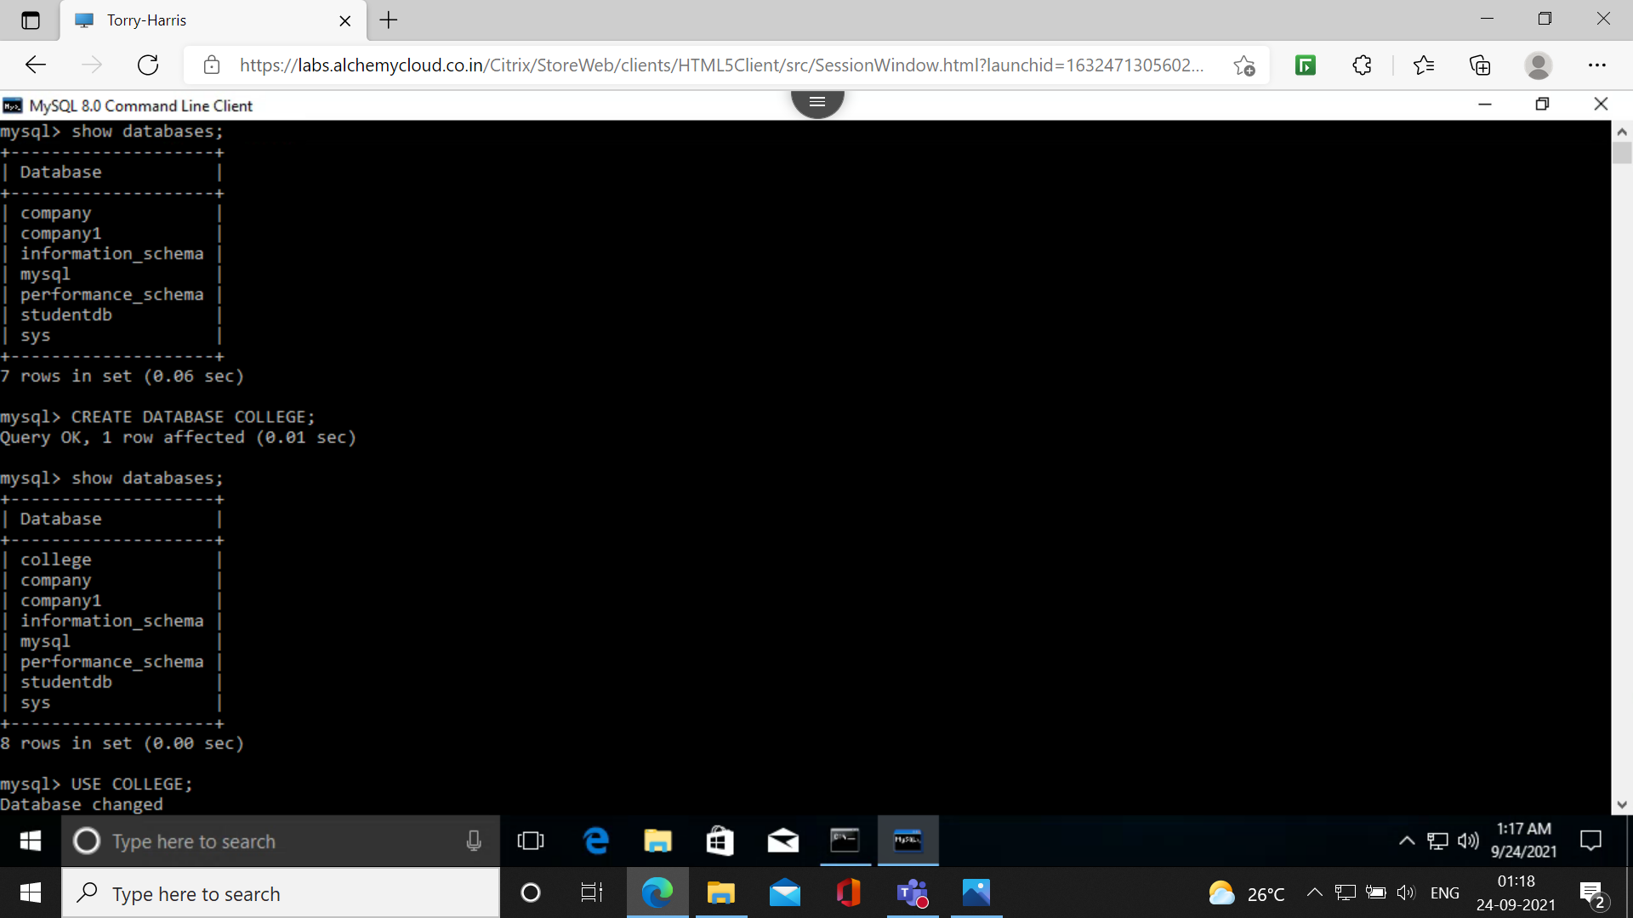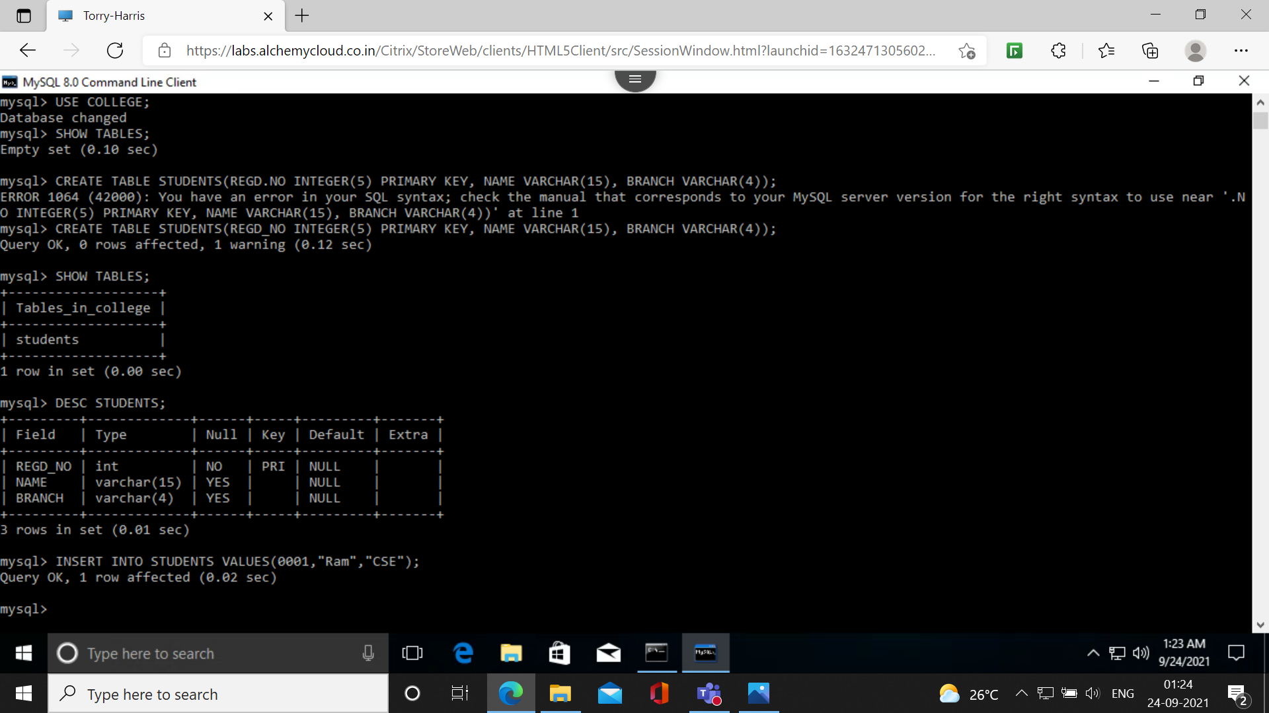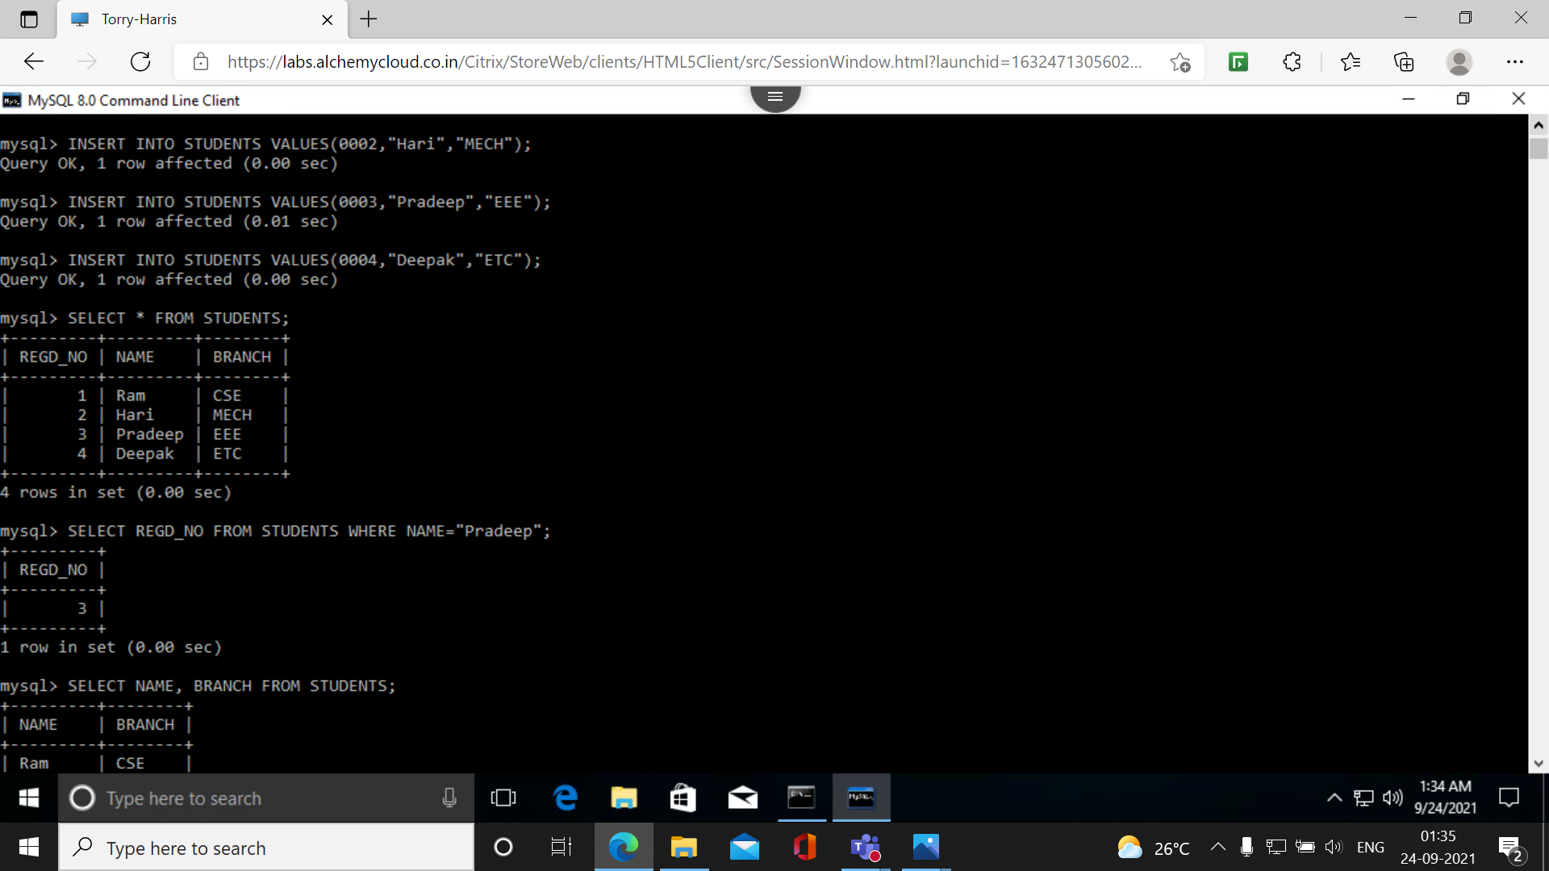**1. Write down the SQL Command which will show the Regd.NO of Pradeep.**

**2. Write down the SQL Command which will show the name and branch column.**

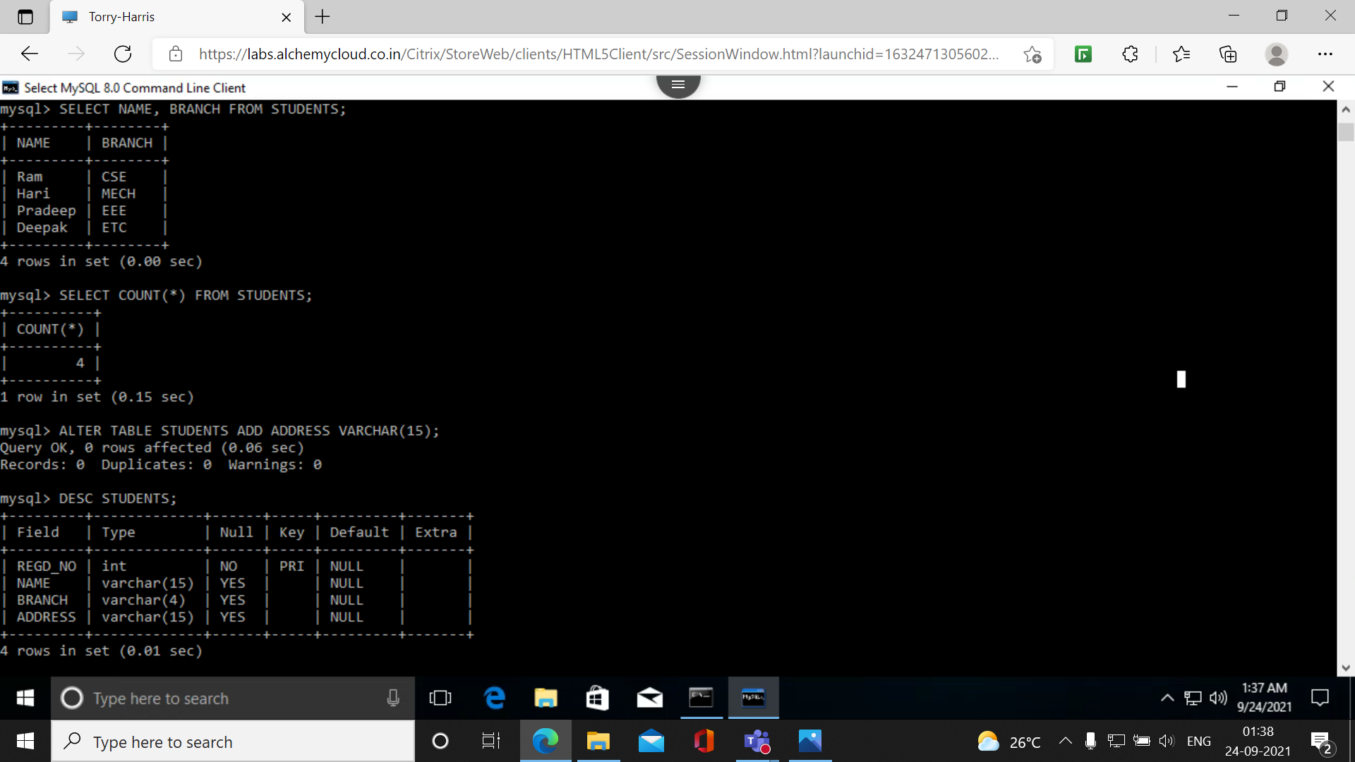**3. Write down the SQL Command which will count number rows exist in STUDENTS table.**

**4. I want to add another column in the STUDENTS table as ”address” How can I do that?**

**Modifications**

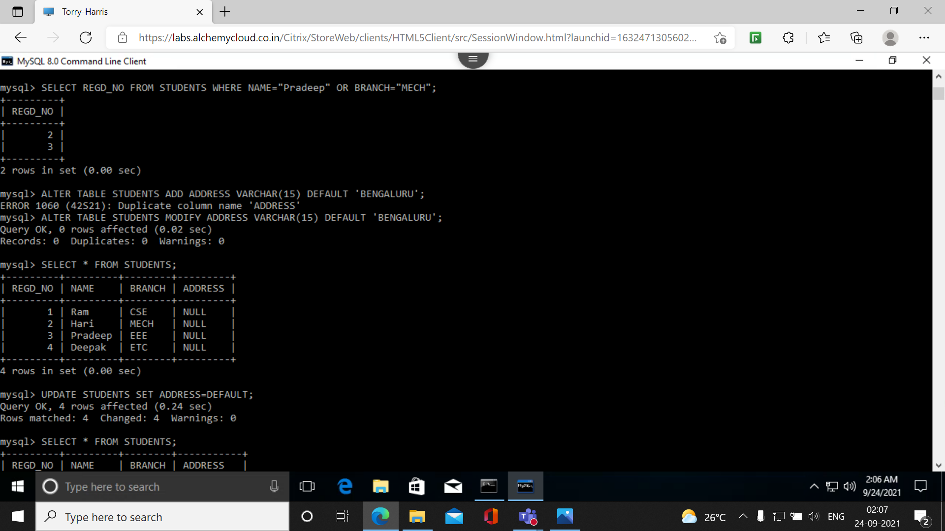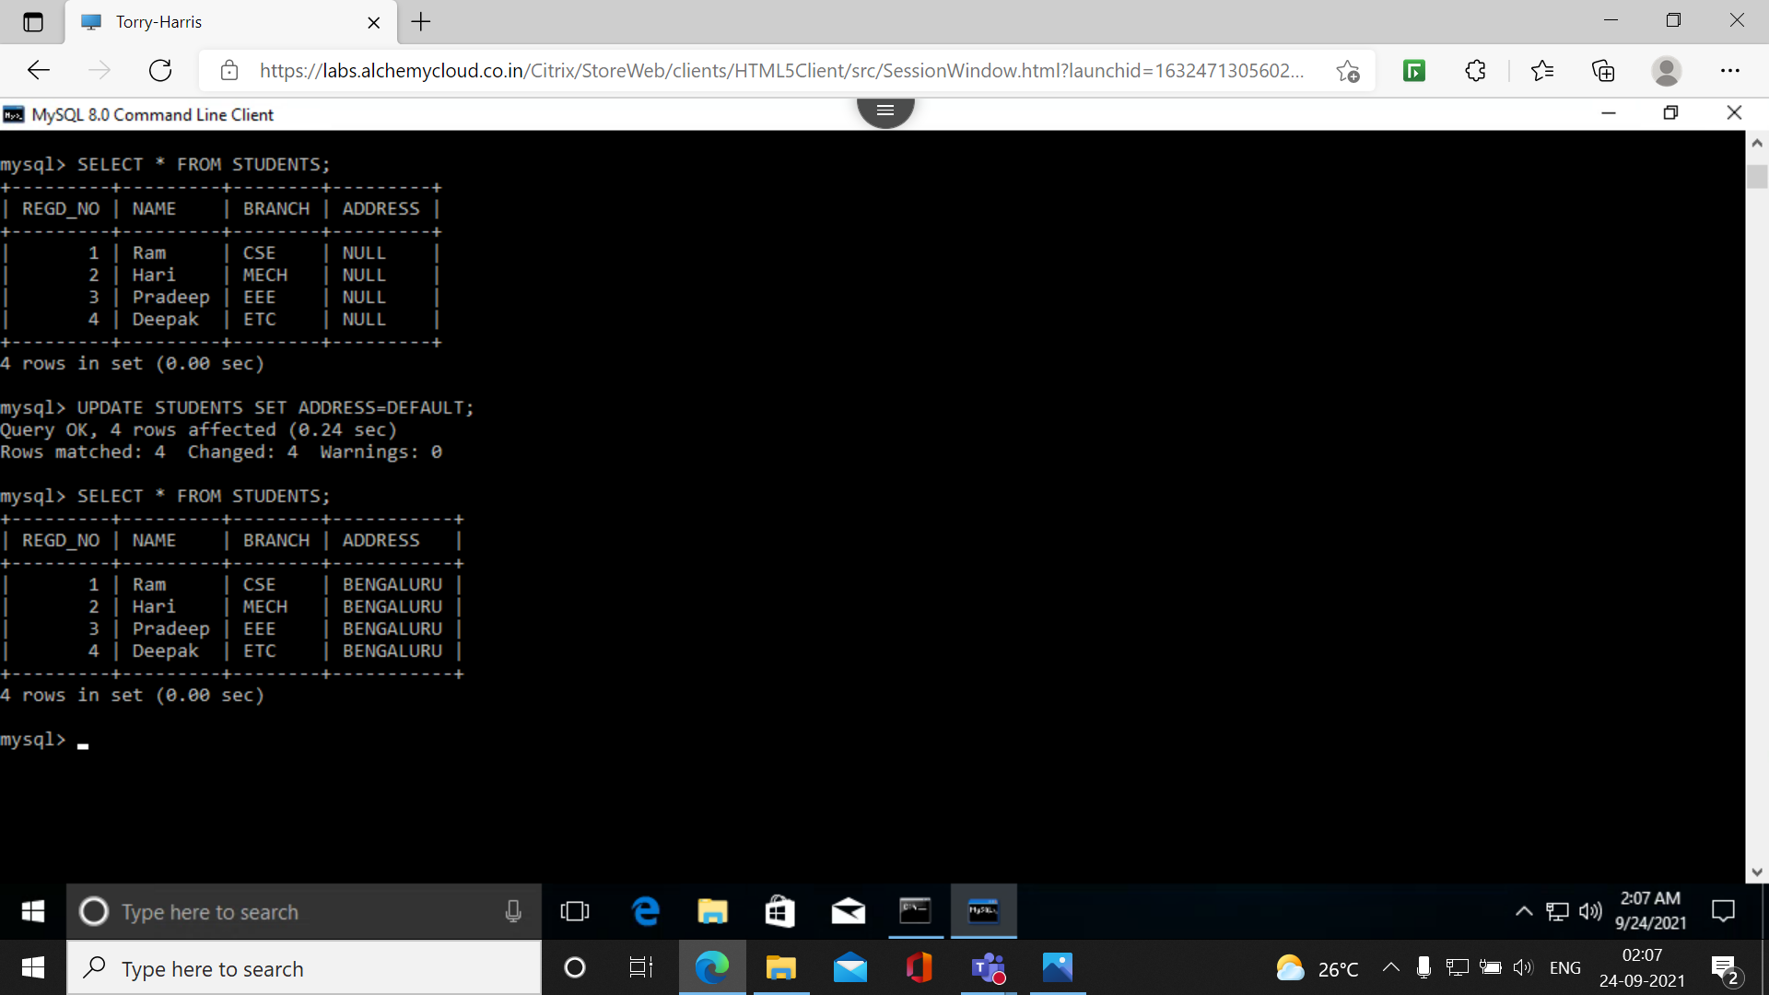

**1.Create the above table**

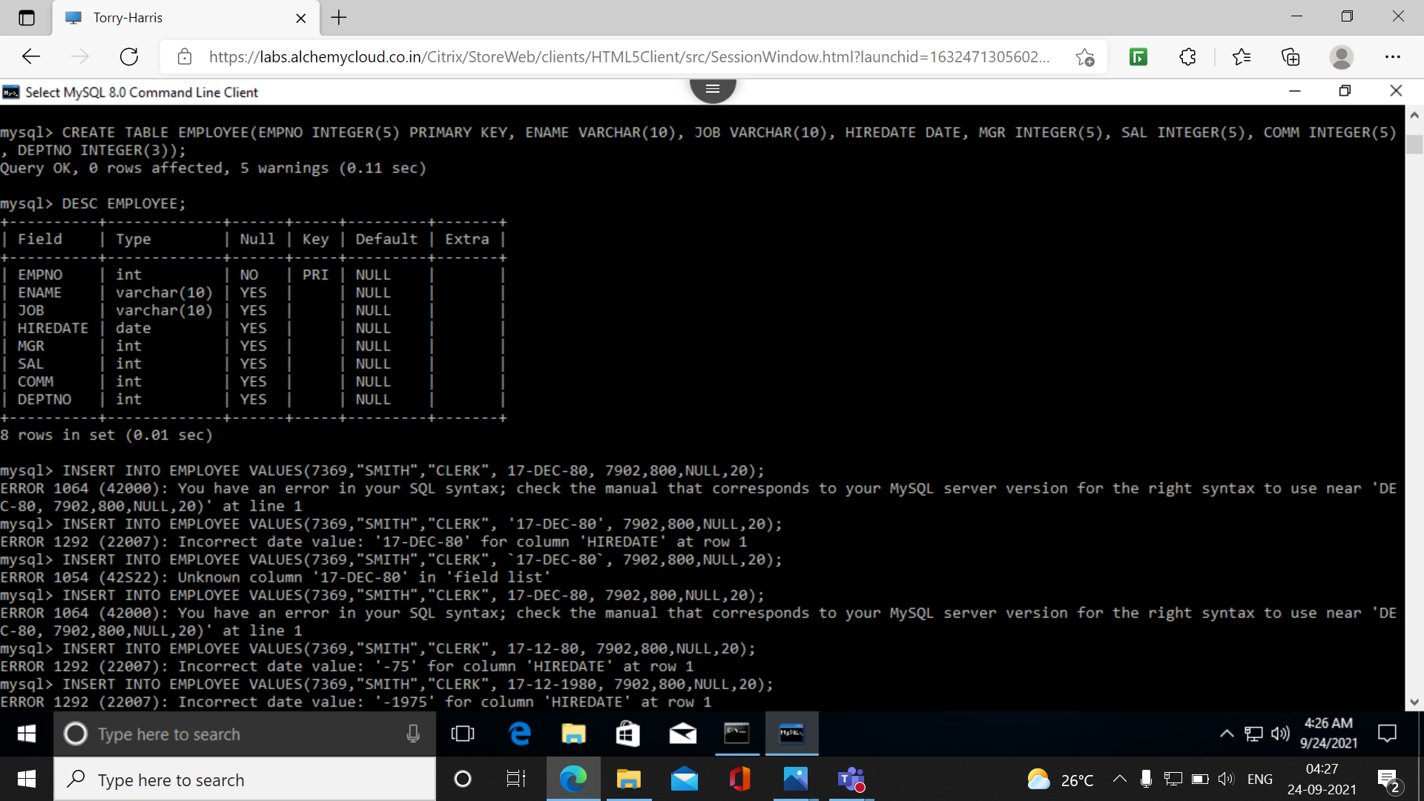

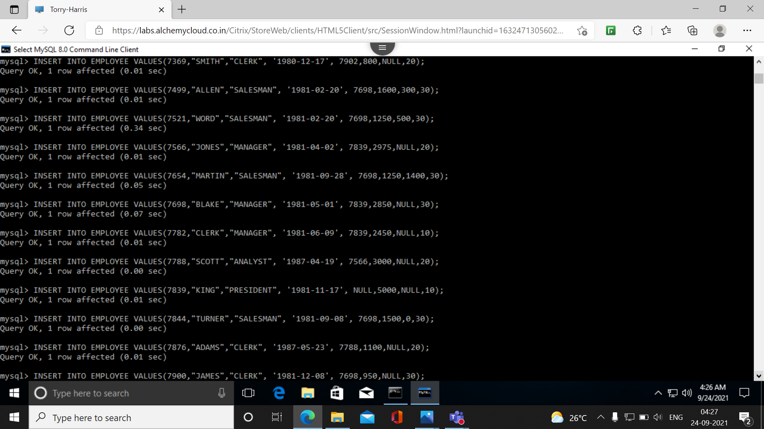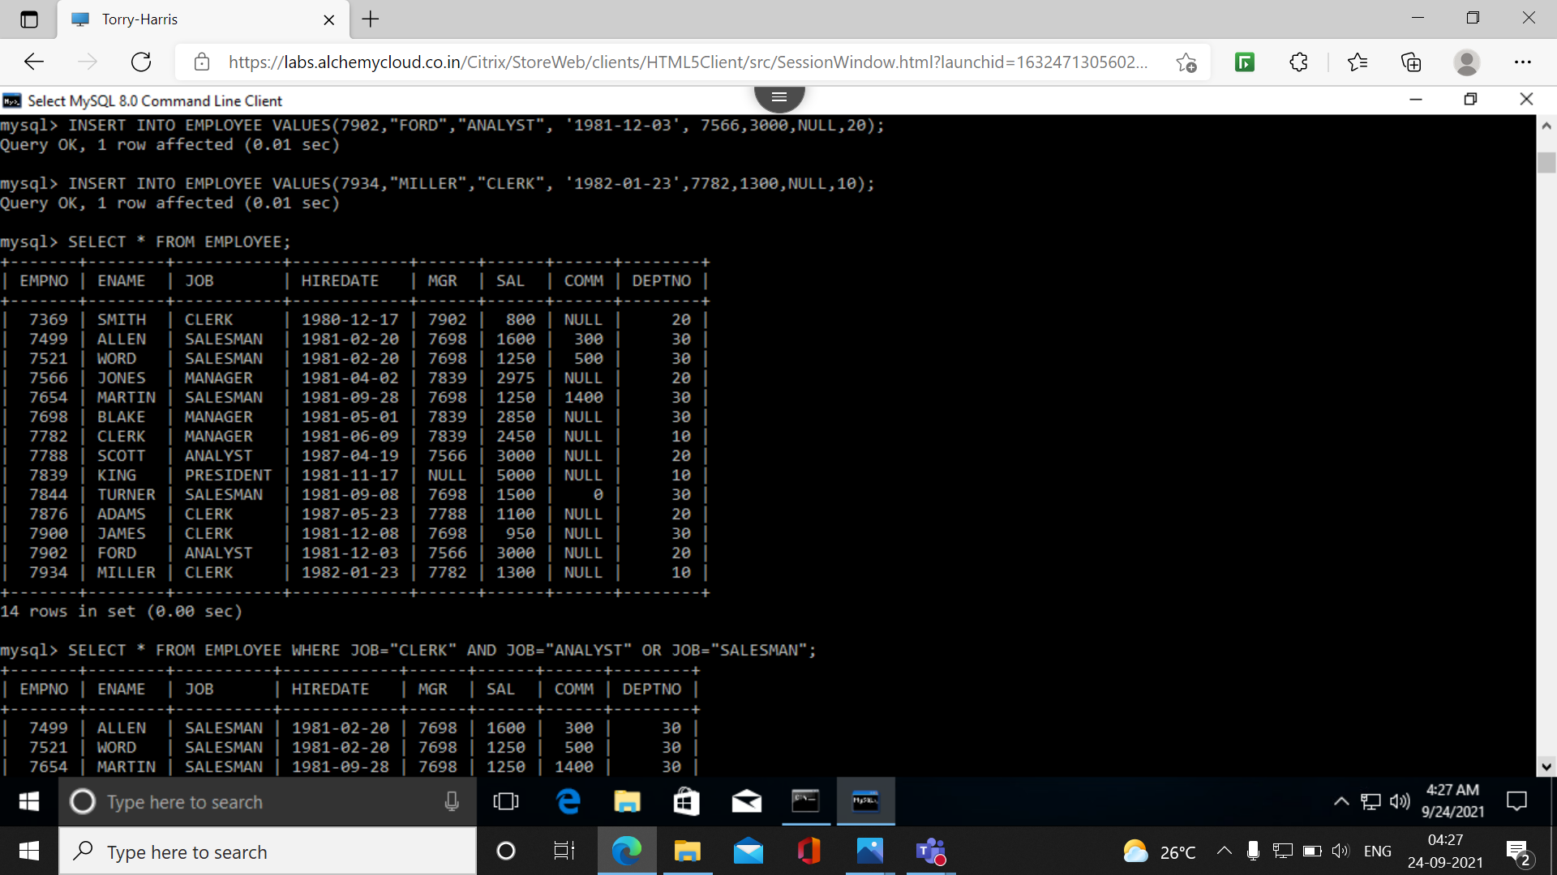**2. Select the employee in department 30.**

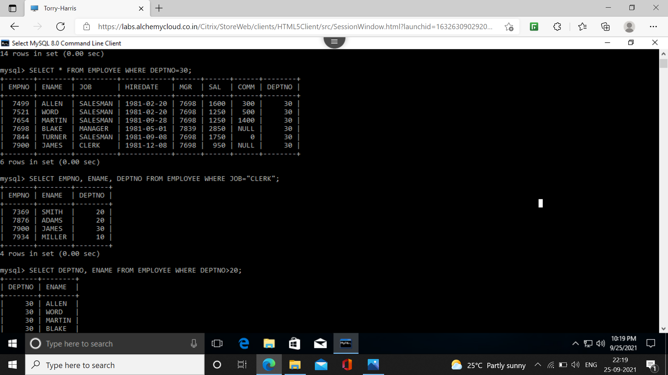3. **List the name, number, and departments of all clerks.**

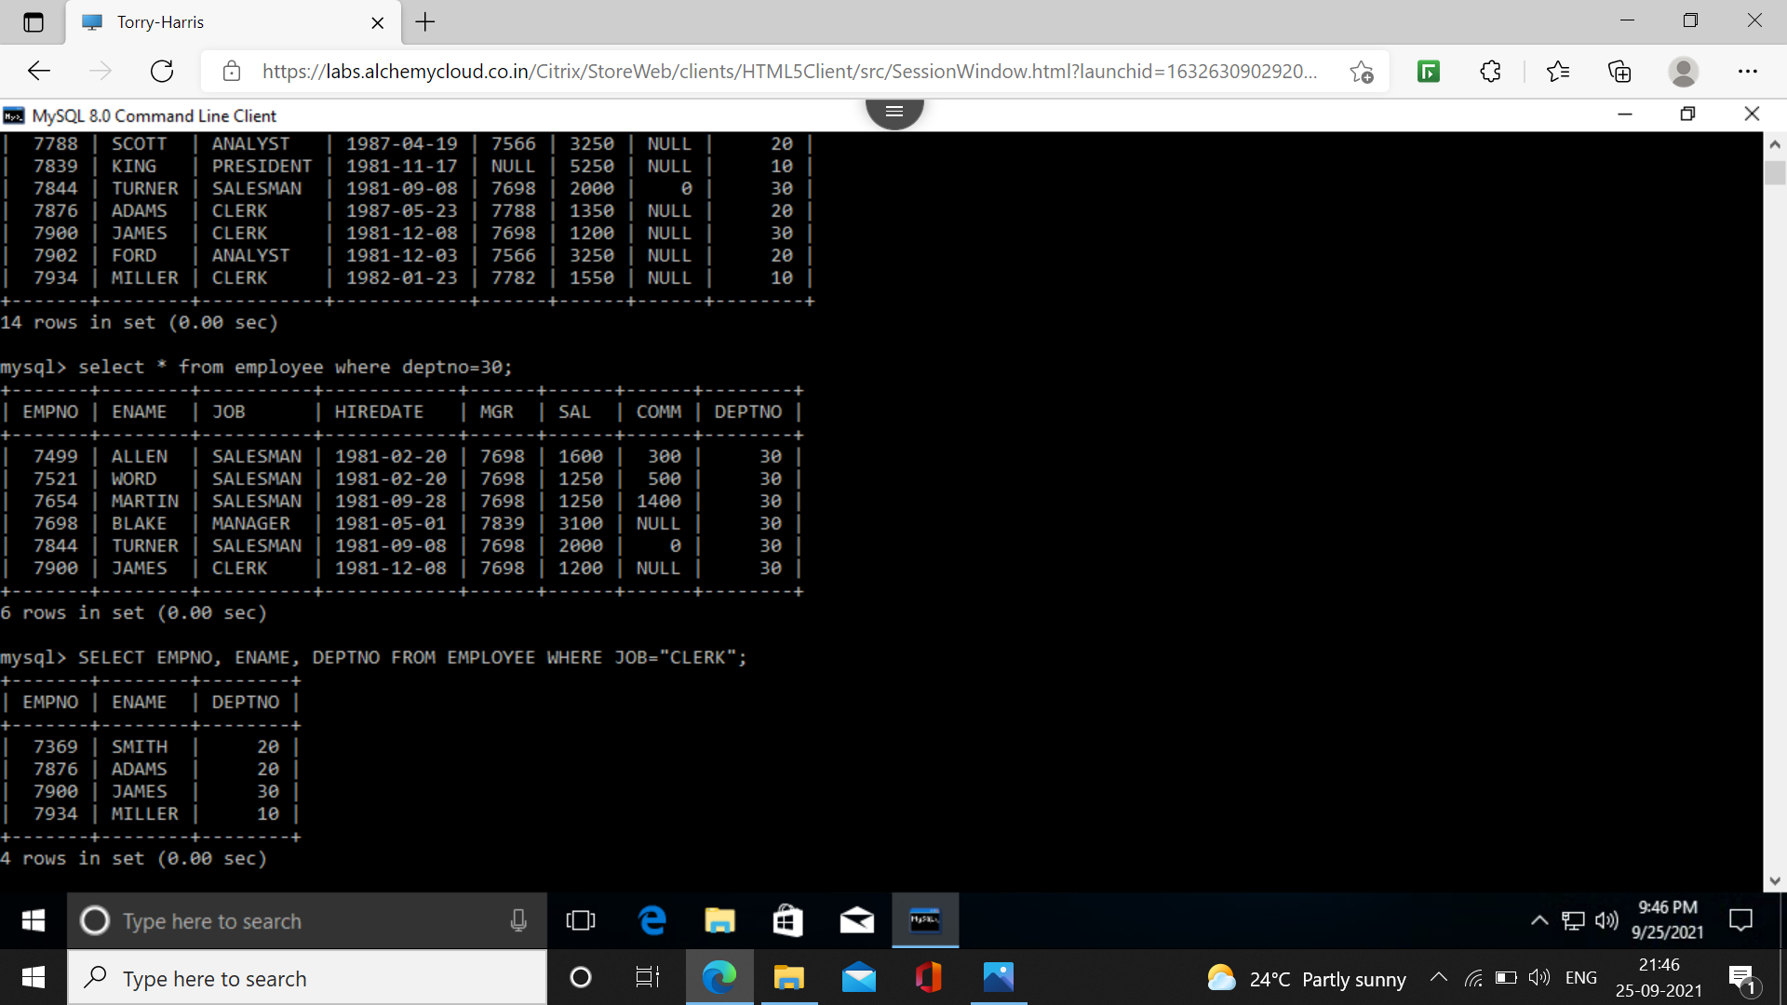**4. Find the department numbers and names of employees of all departments with deptno greater than 20.**

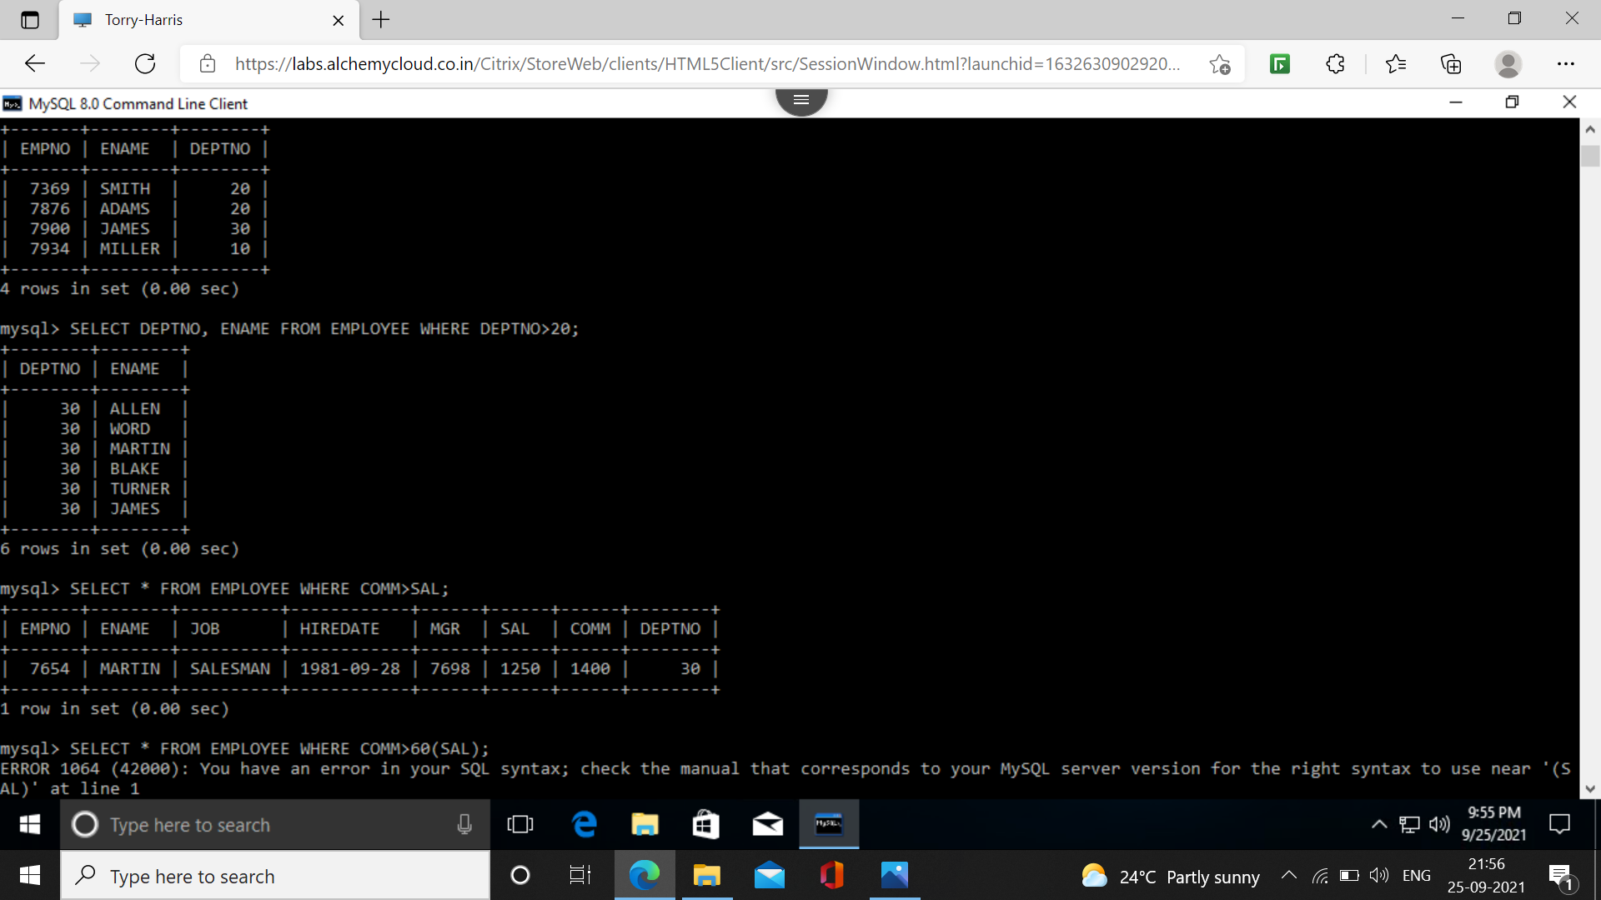**5. Find the employees whose commission is greater than their salaries.**

**6. Find the employees whose commission is greater than 60% of their salaries.**

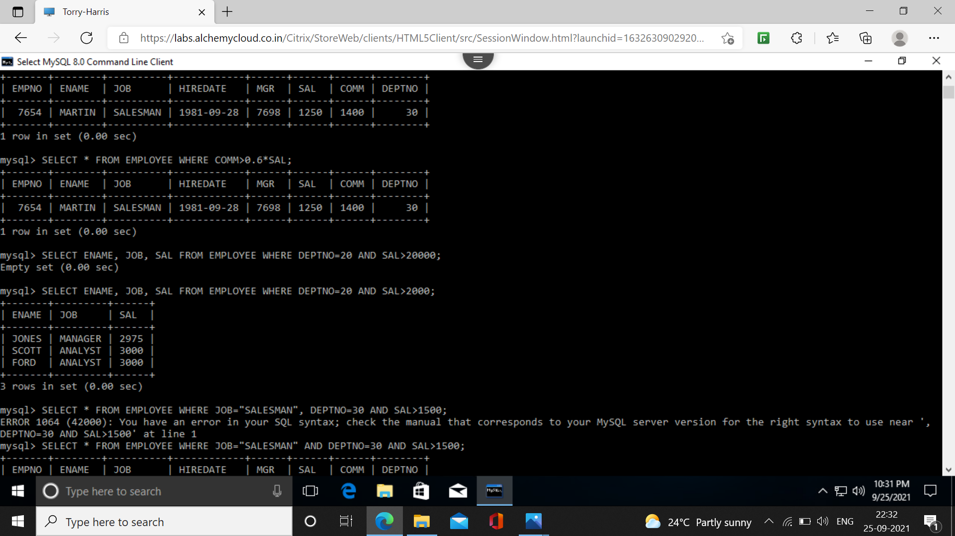**7. List name, job and salary of all employees in department 20 who earn more than 2000/-.**

**8. Find all salesmen in department 30 whose salary is greater than 1500/-.**

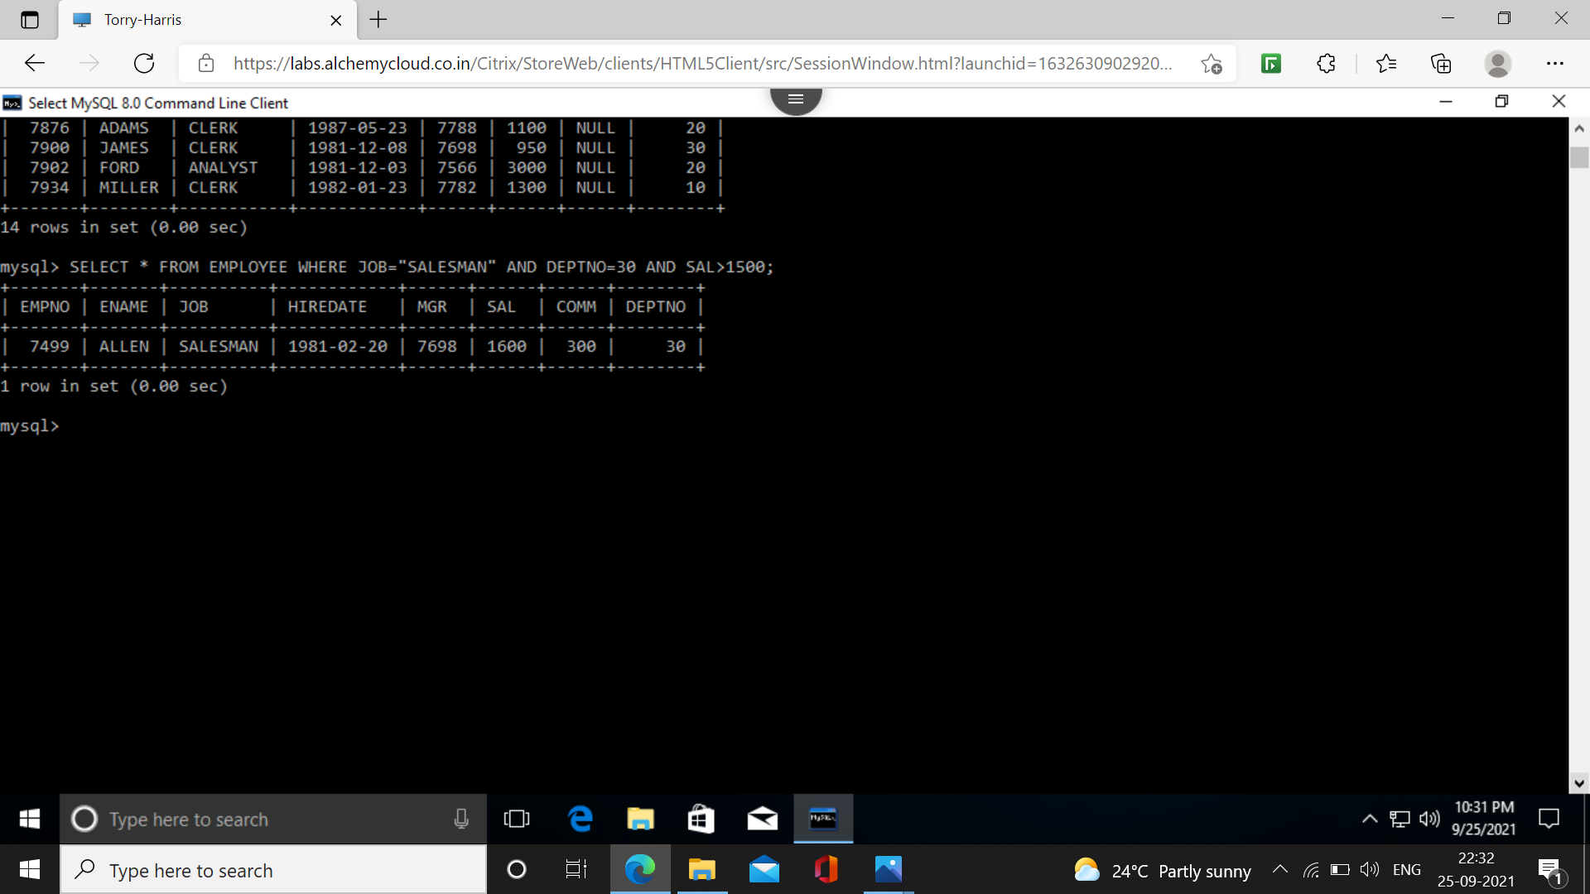**9. Find all employees whose designation is either manager or president.**

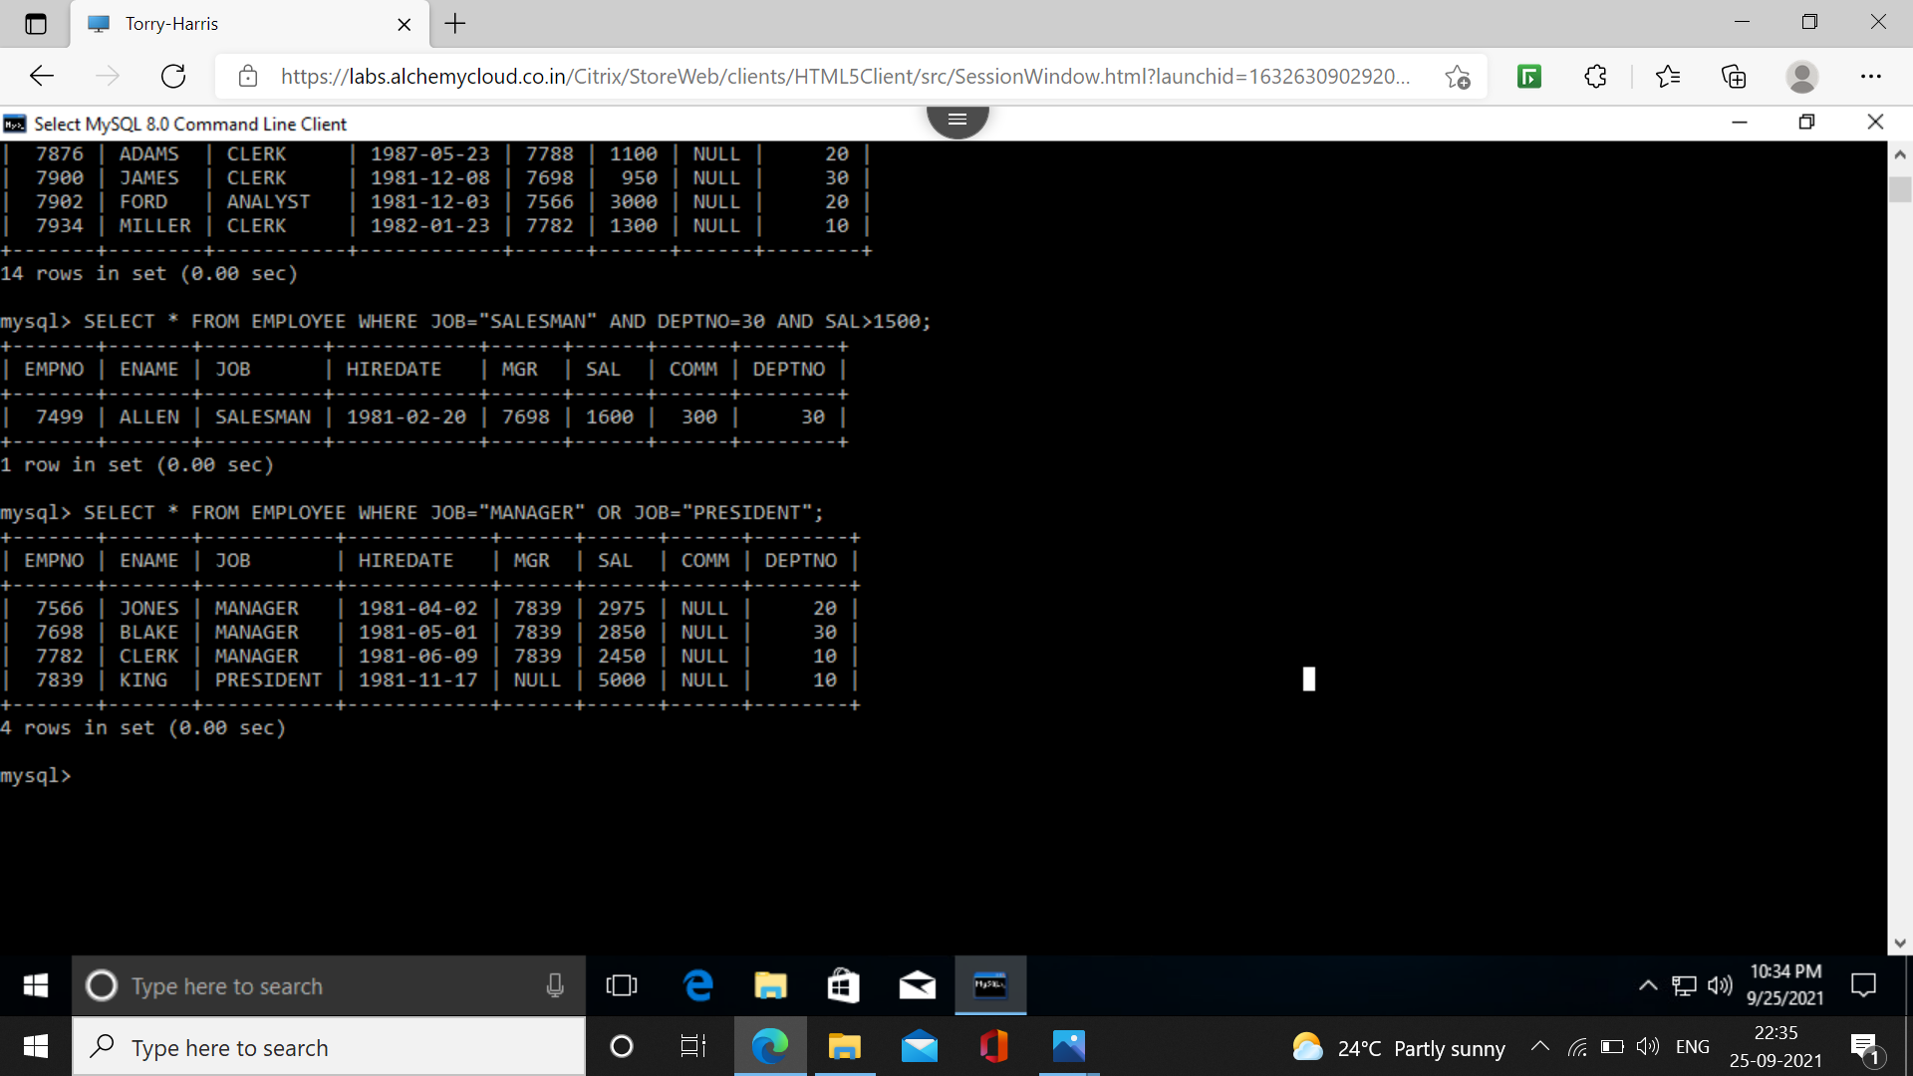**10. Find all managers who are not in department 30.**

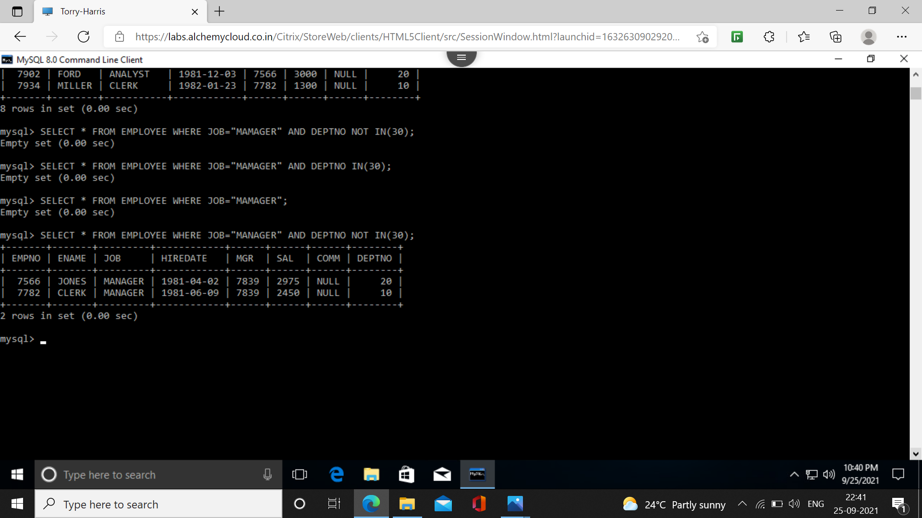**11. Find all the details of managers and clerks in dept 10.**

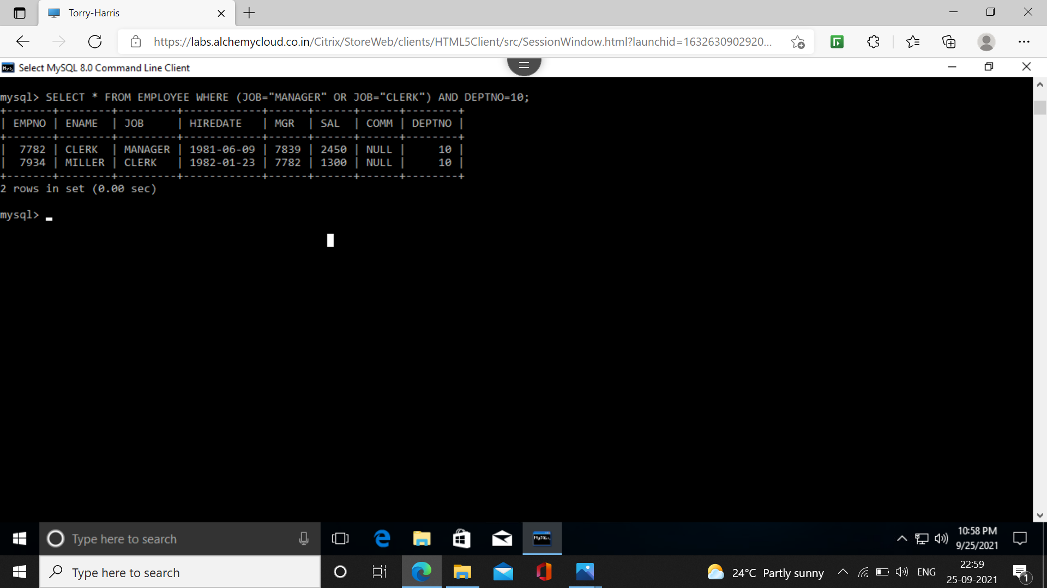**12. Find all details of all the manager (in any dept) and clerks in dept 20.**

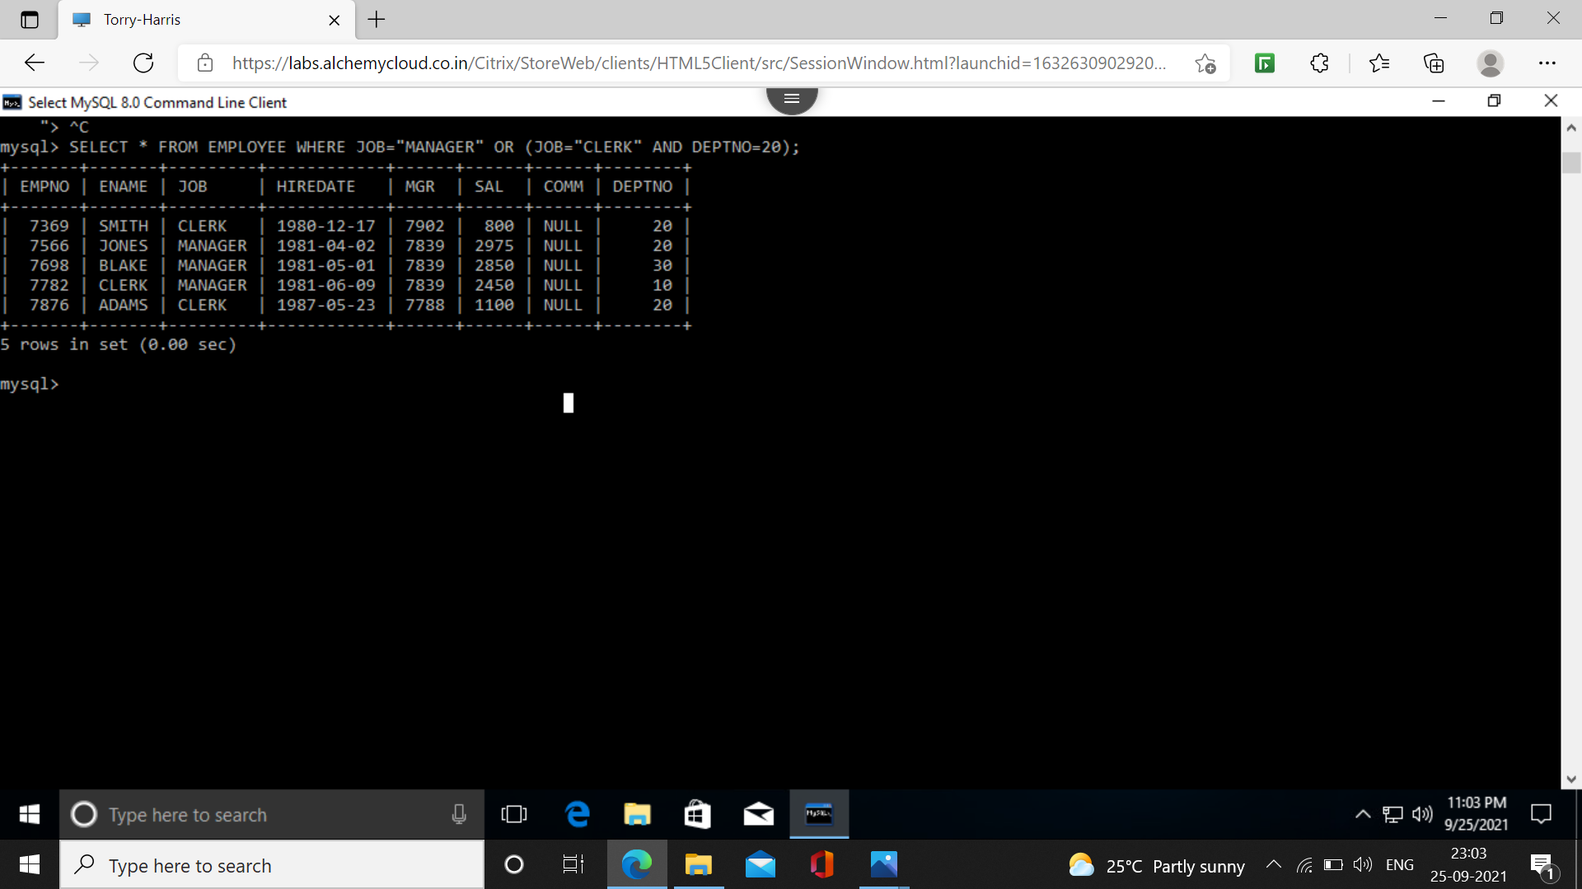**13. Find all details of all the manager in dept. 10 and clerks in dept 20 and all employees who are neither managers nor clerks but whose salary is more than or equal to 2000/-.**

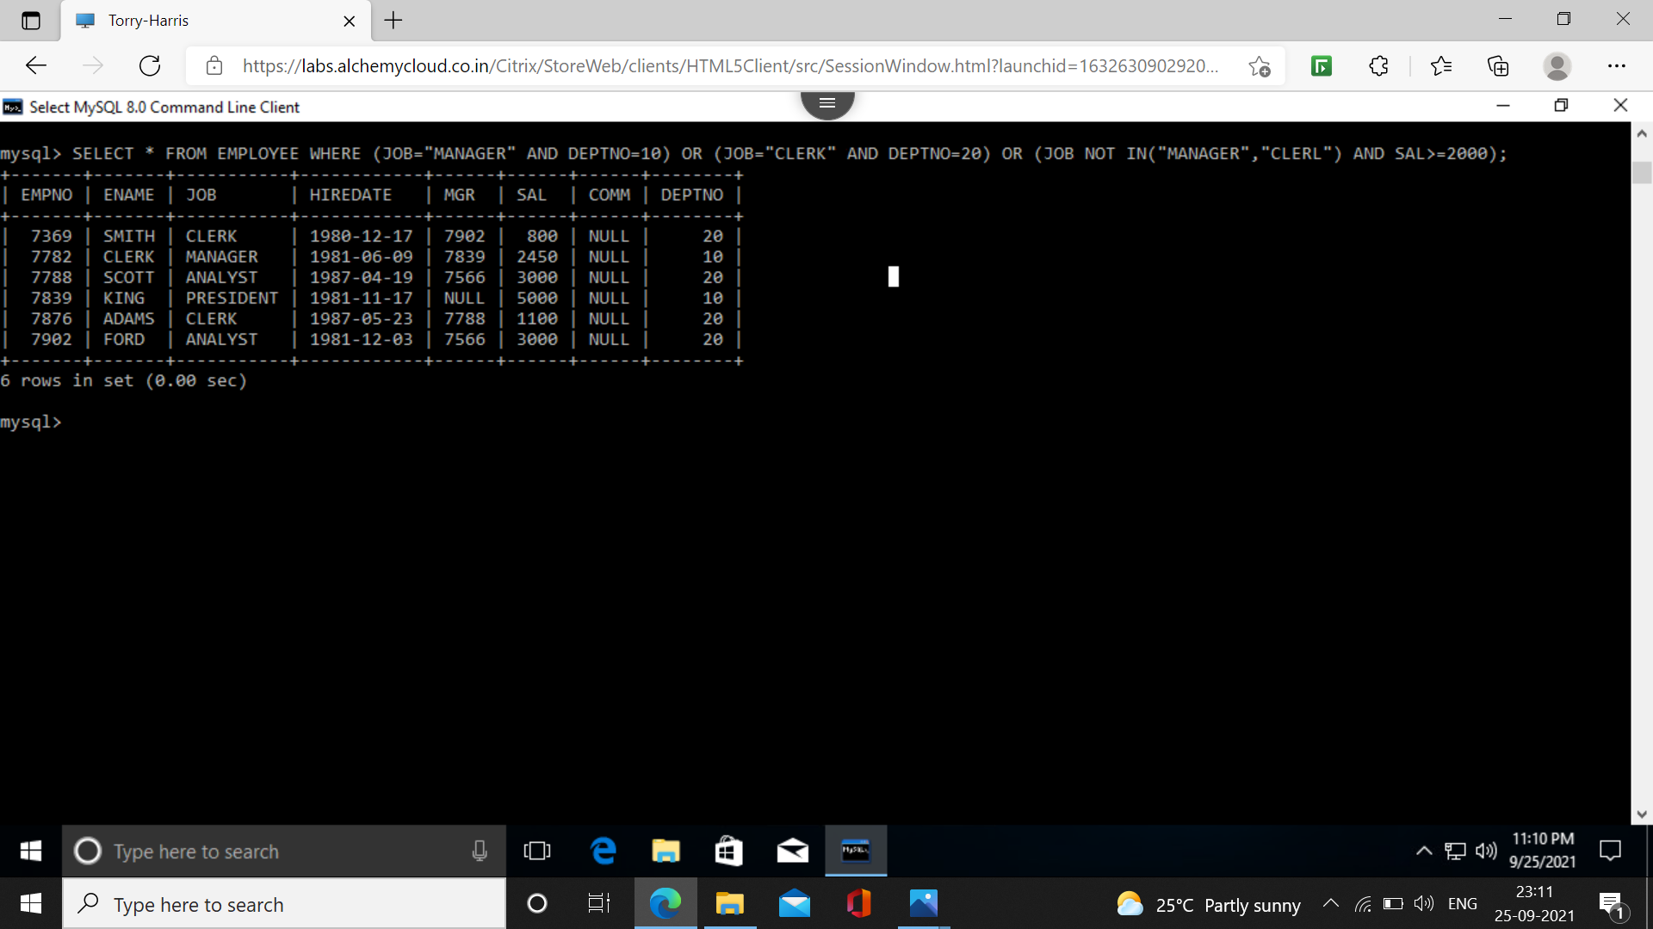**14. Find the names of anyone in dept. 20 who is neither manager nor clerk.**

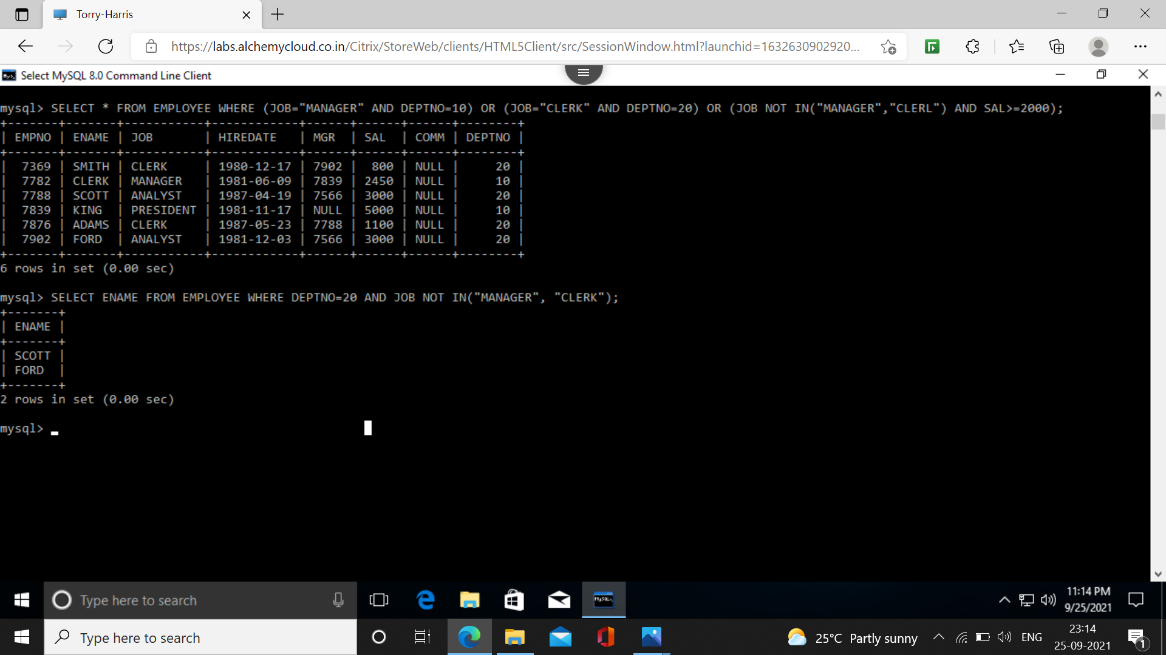**15. Find the names of employees who earn between 1200/- and 1400/-.**

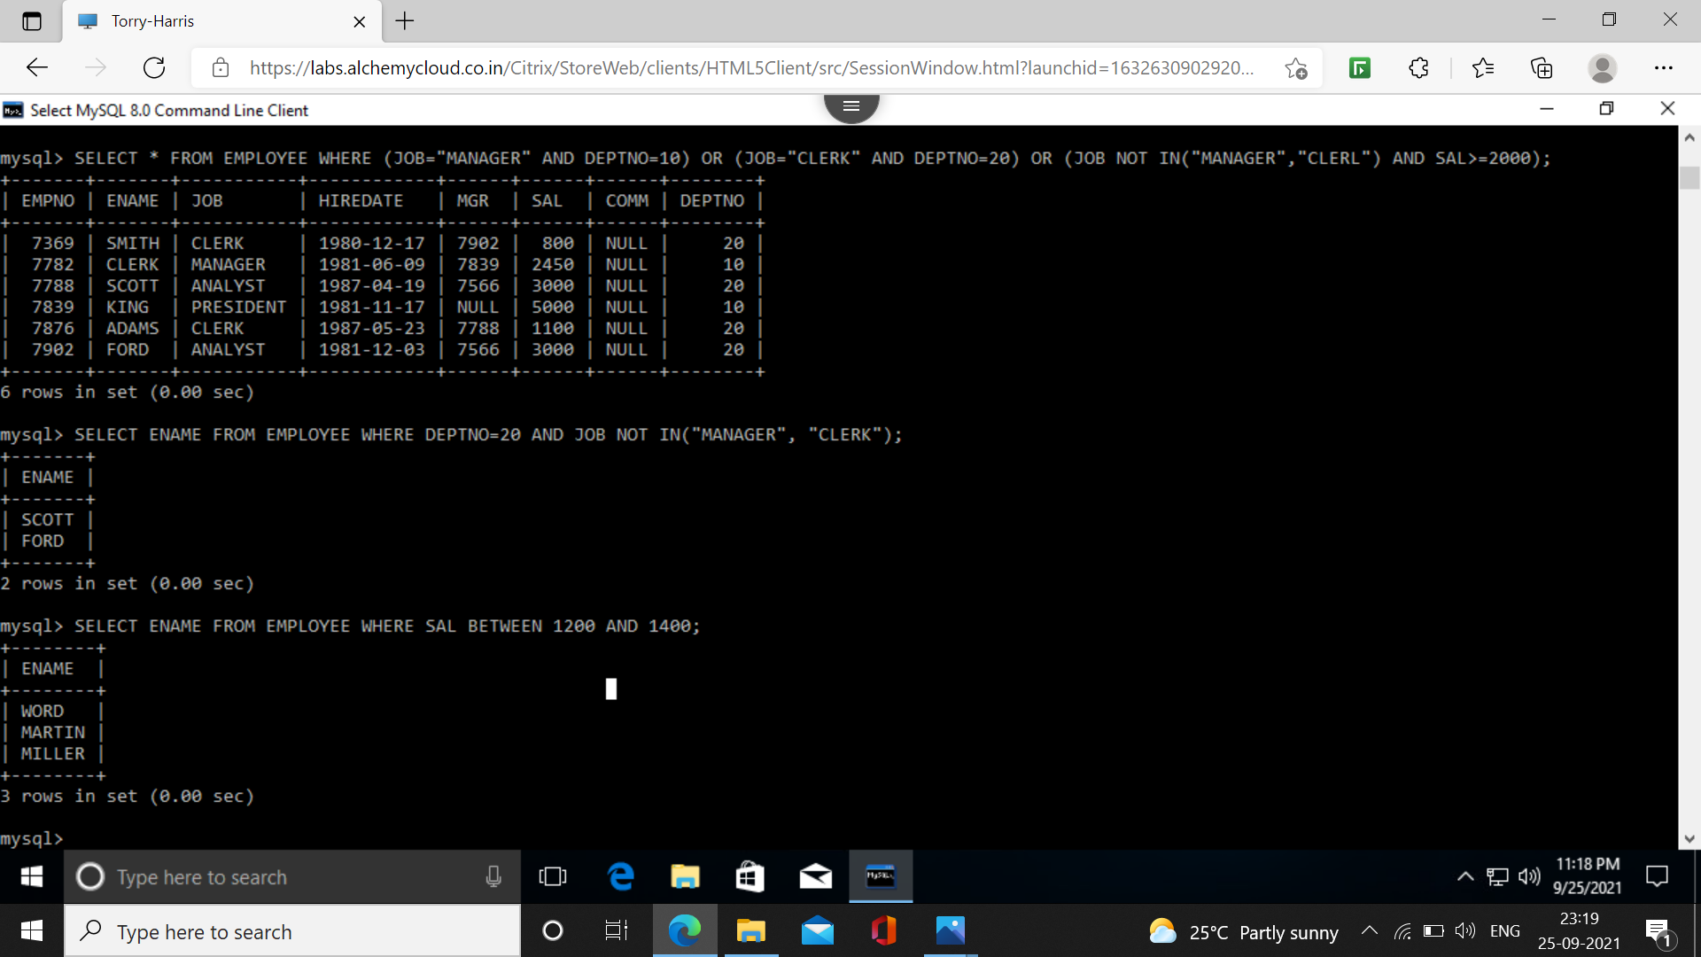**16. Find the employees who are clerks, analysts or salesmen.**

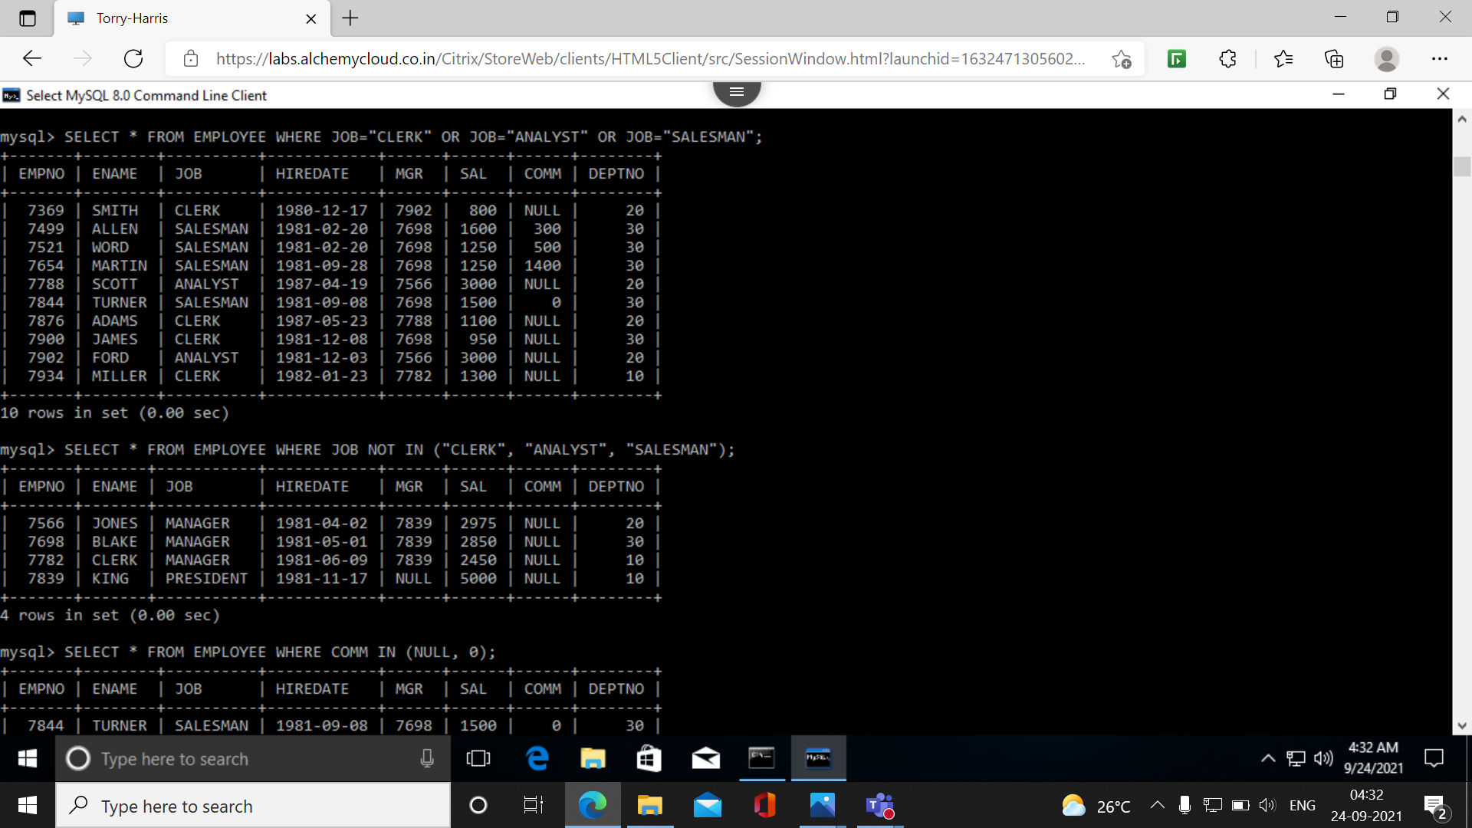**17. Find the employees who are not clerks, analysts or salesmen.**

**18. Find the employees who do not receive commission.**

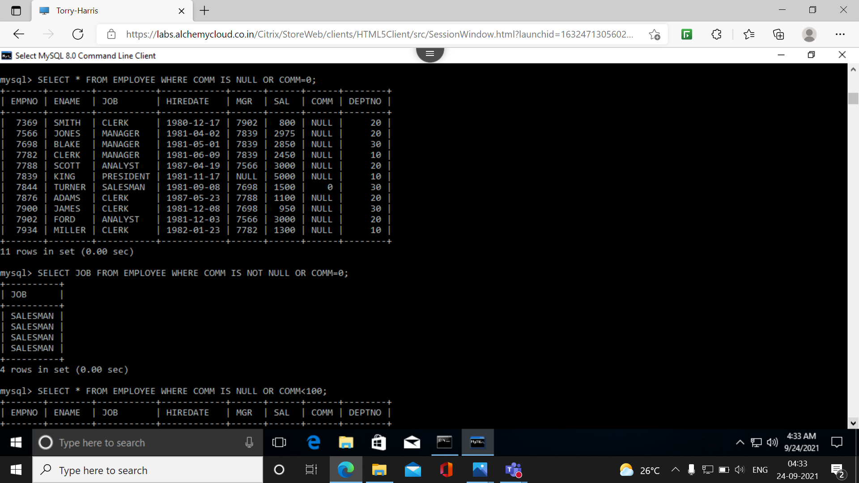**19. Find the different jobs of employees receiving commission.**

**20. Find the employees who do not receive commission or whose commission is less than 100/-.**

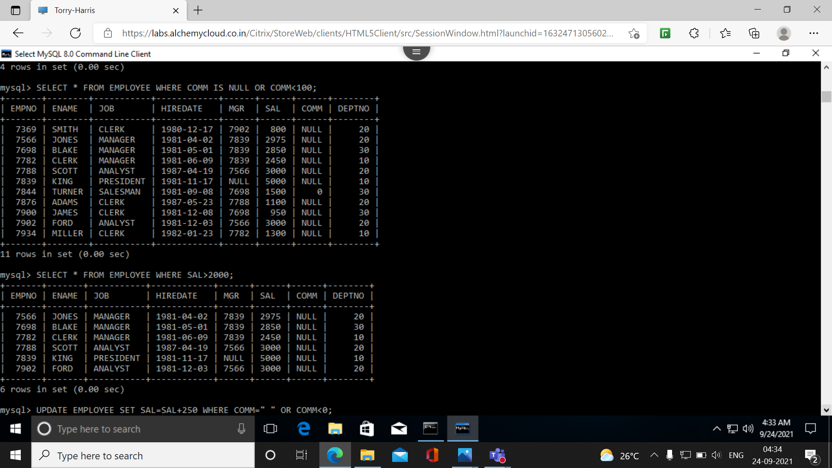**21. If all the employees are not receiving commission is entitles to a bonus of Rs. 250/- show the net earnings of all the employees.**

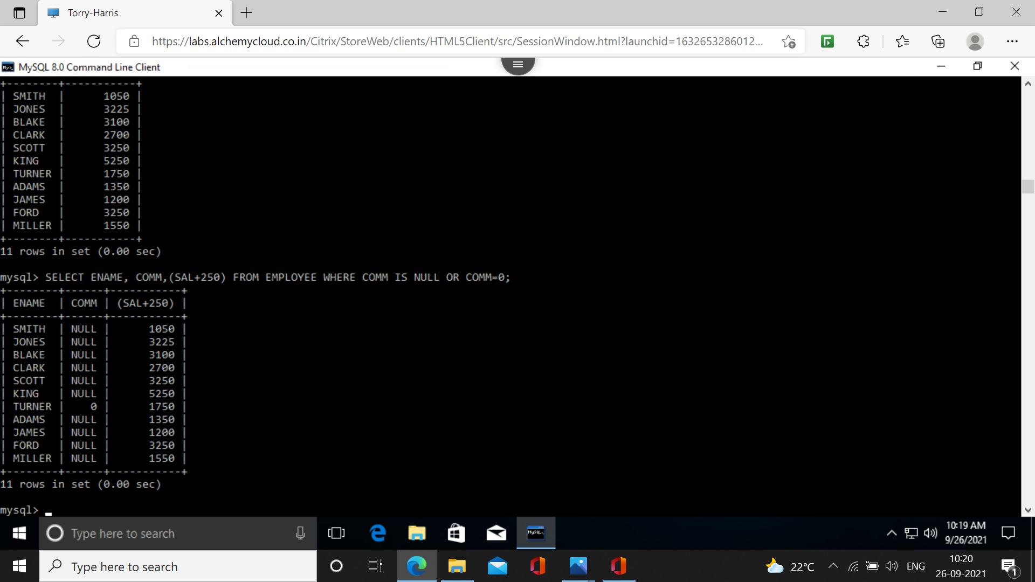**22. Find all the employees whose total earning is greater than 2000/-.**

**23. Find all the employees whose name begins or ends with ’M’.**

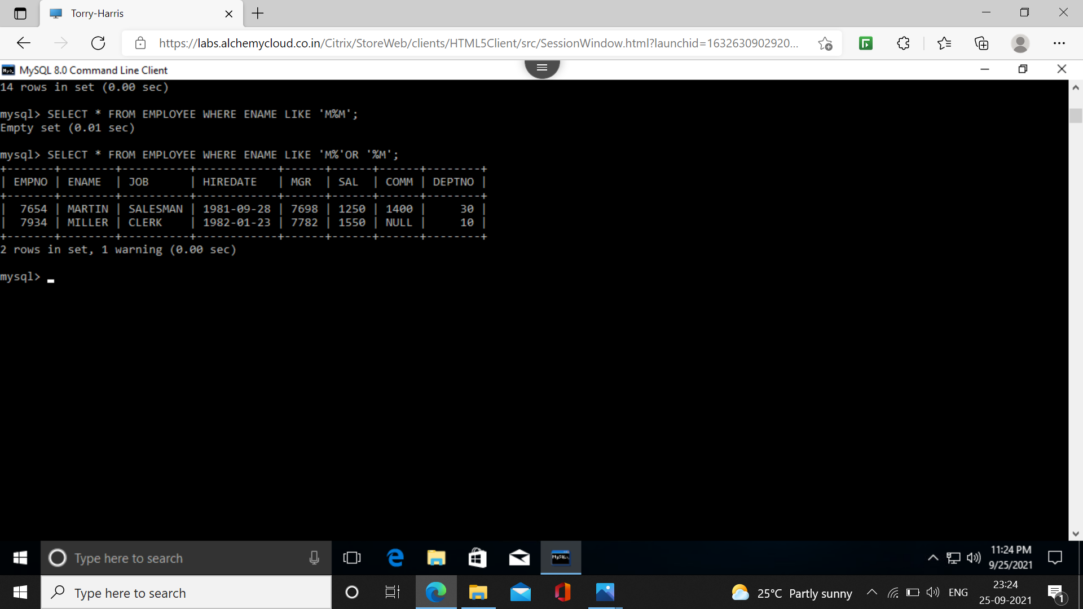**24. Find all the employees whose names contain the letter ’M’ in any case.**

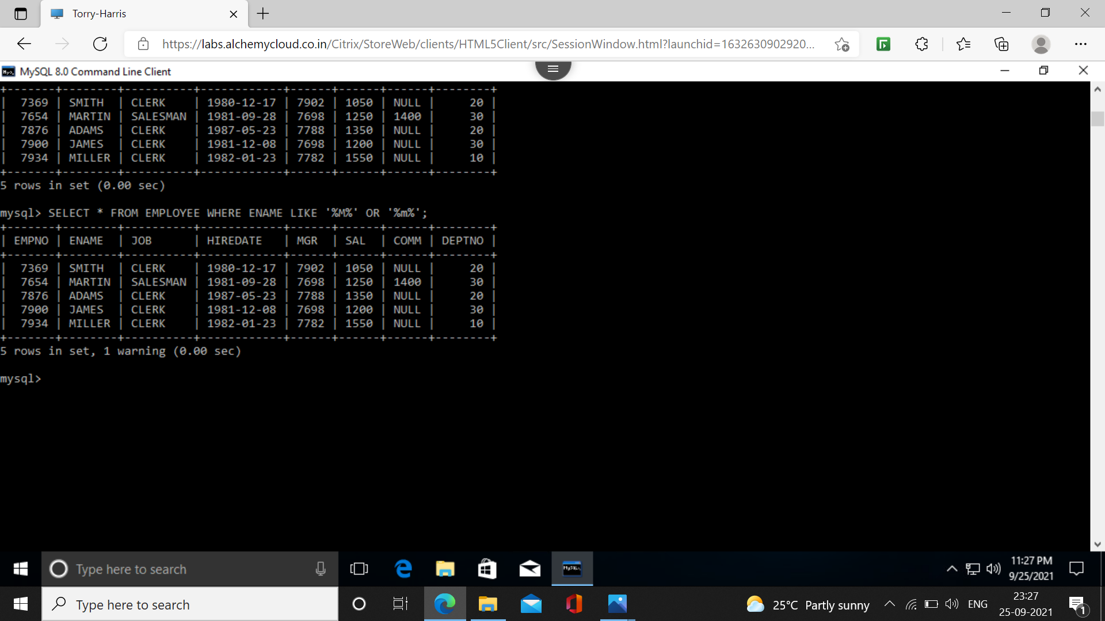**25. Find all the employees whose names are upto 15 character long and have letter ’R’ as 3rd character of their names.**

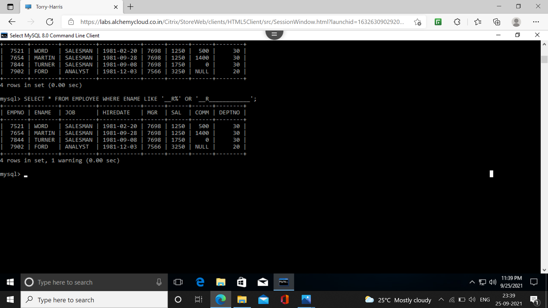**26. Find all the employees who were hired in the month of February (of any year).**

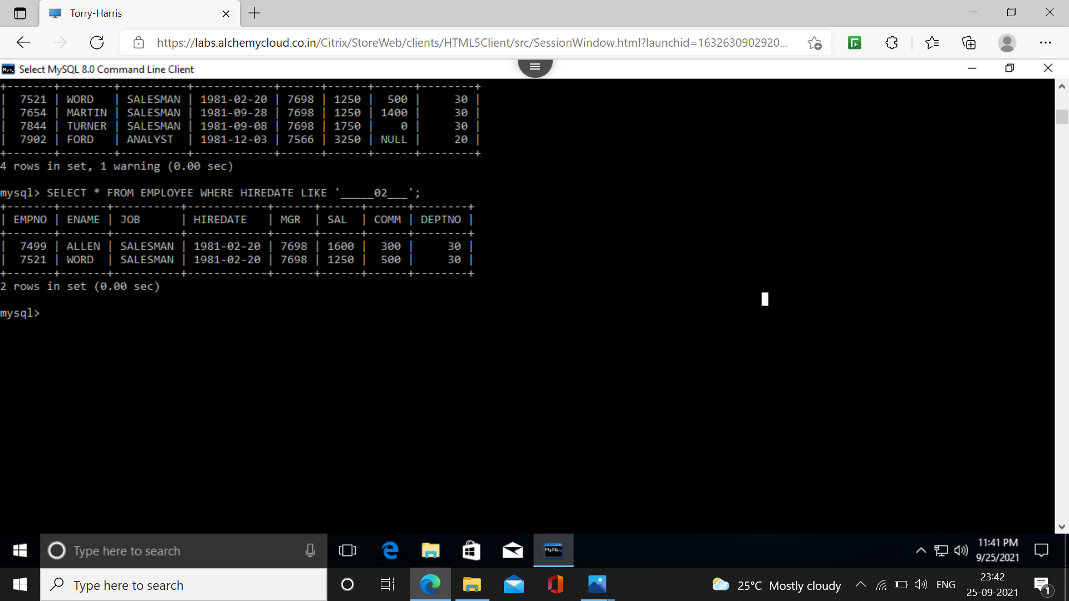**27. Find all the employees who were hired on last day of the month.**

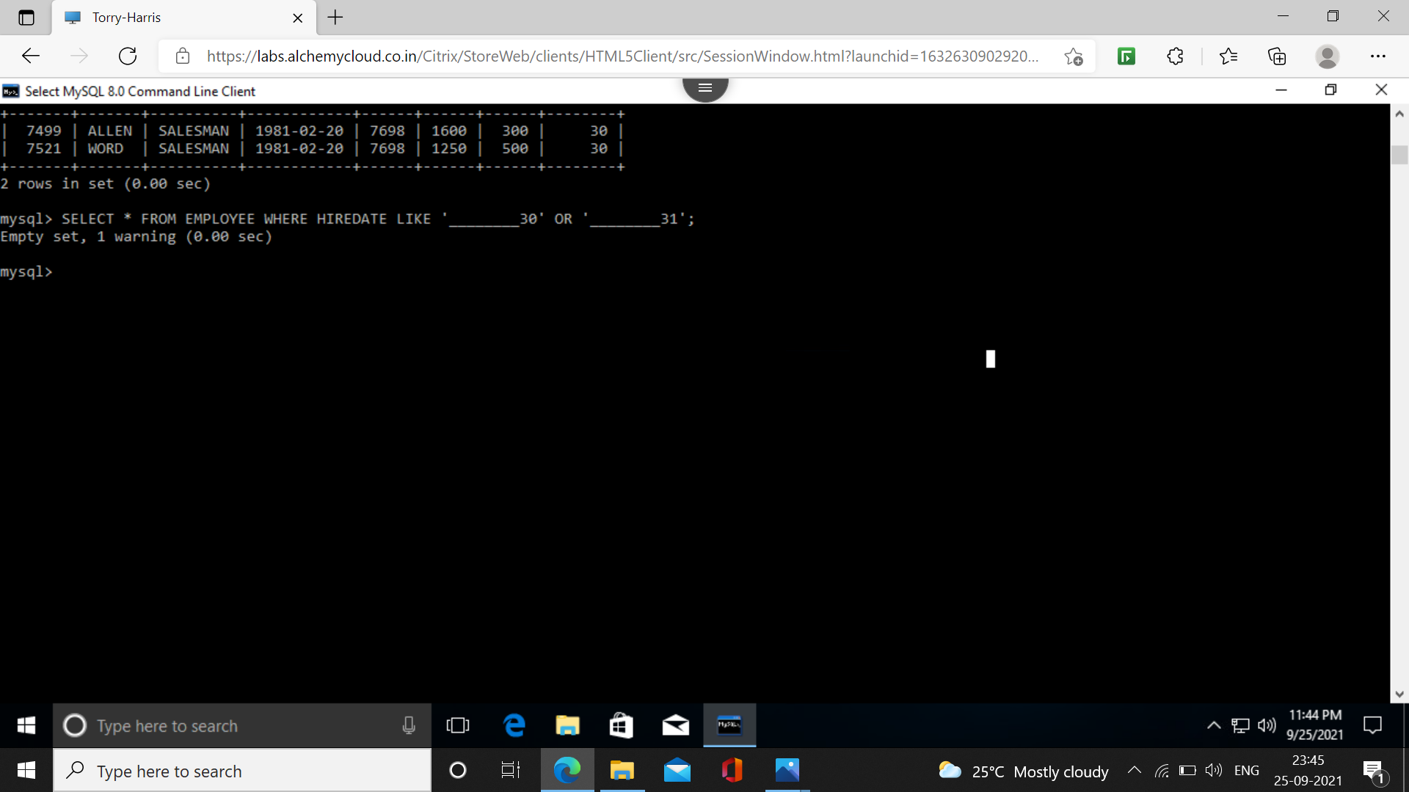**28. Find all the employees who were hired more than 2 years ago.**

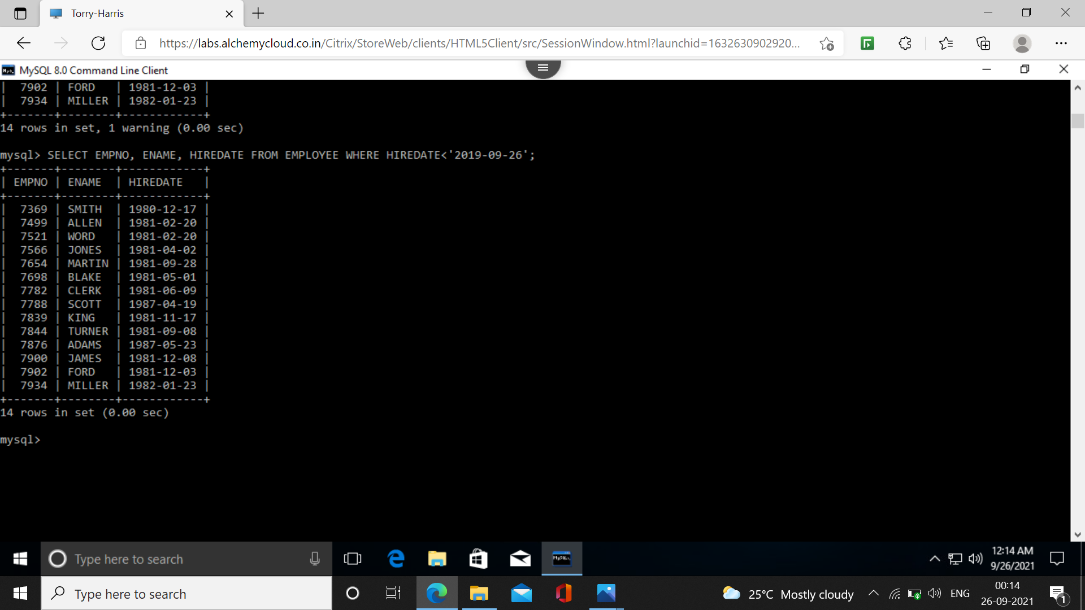**29. Find the managers hired in the year 2003.**

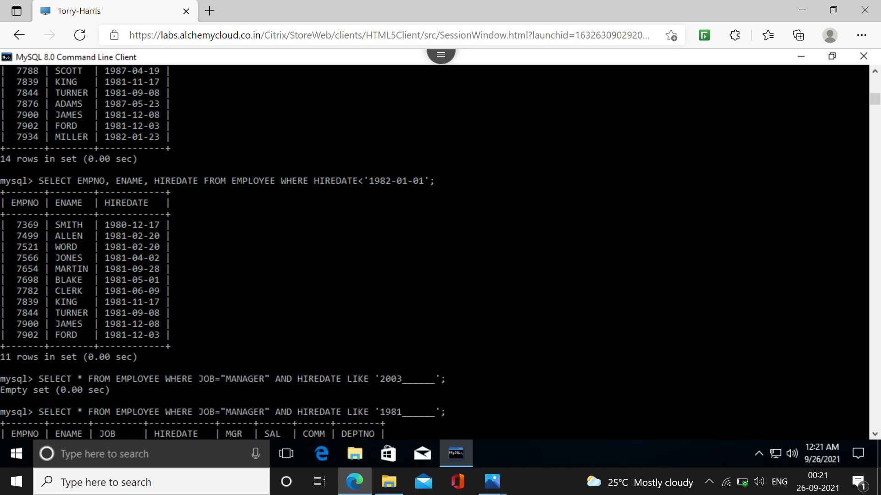**30. Display the names and jobs of all the employees separated by a space.**

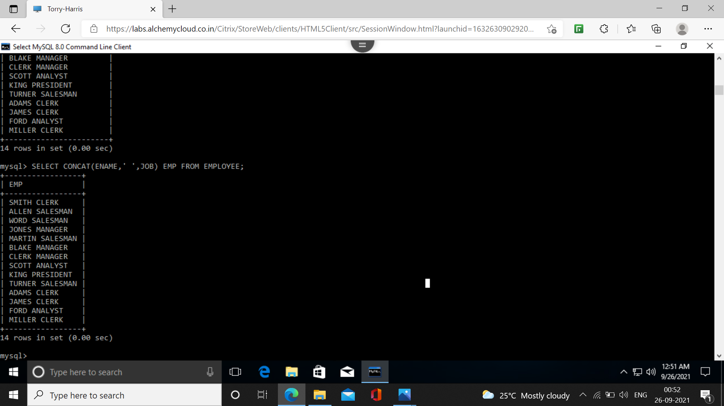**31. Display the names of all the employees right aligning them to 15 characters.**

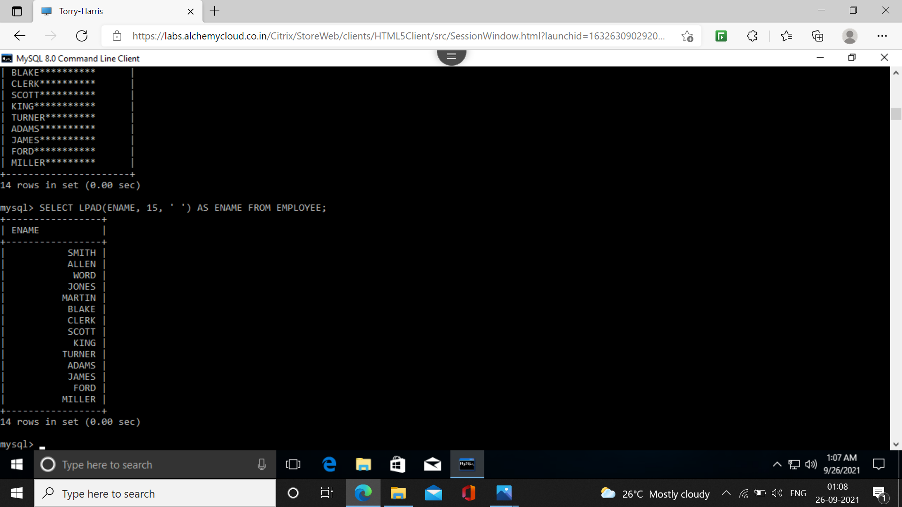**32.Display the names of all the employees padding them to the right up to 15 characters with ’*’.**

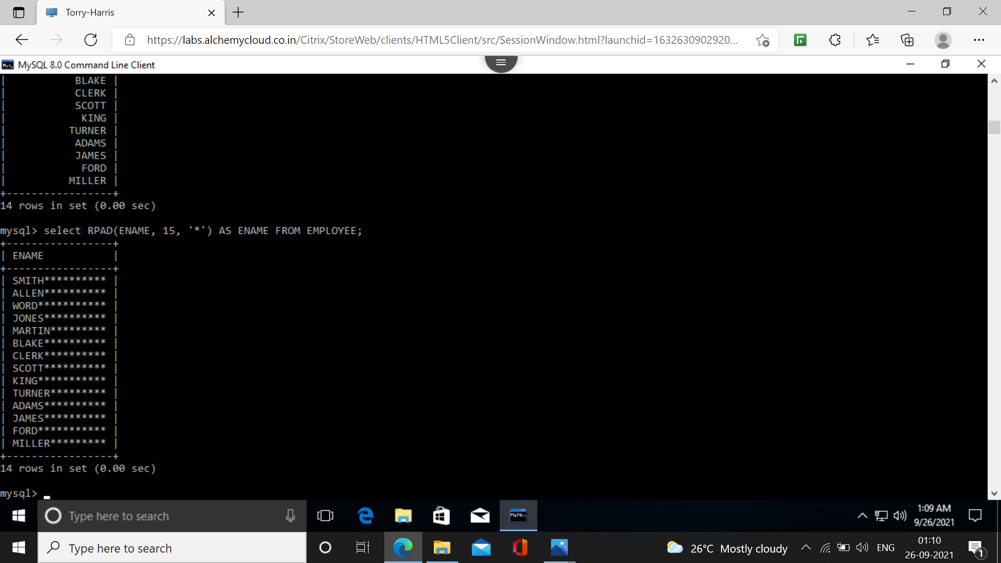**33. Display the names of all the employees without any leading ’A’.**

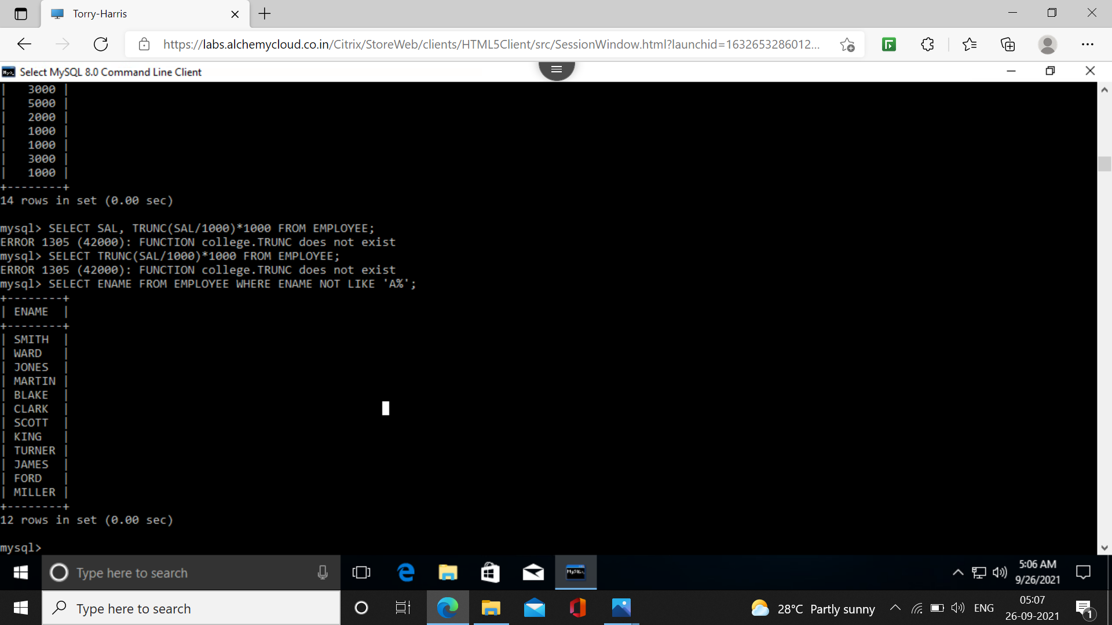**34. Display the names of all the employees without any trailing ’R’.**

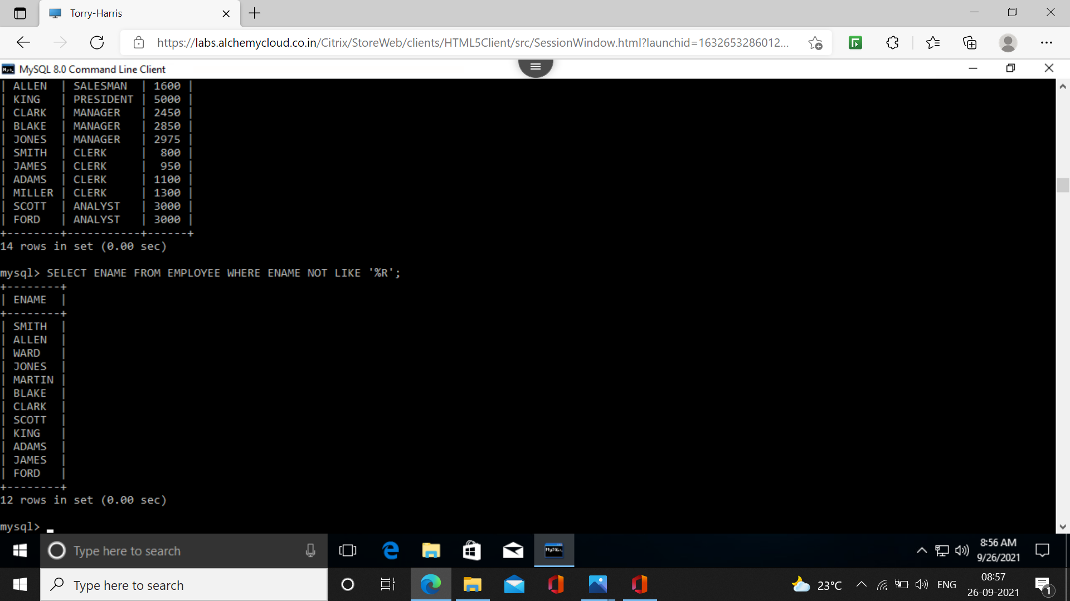**35. Show the first 3 and last characters of the names of all the employees.**

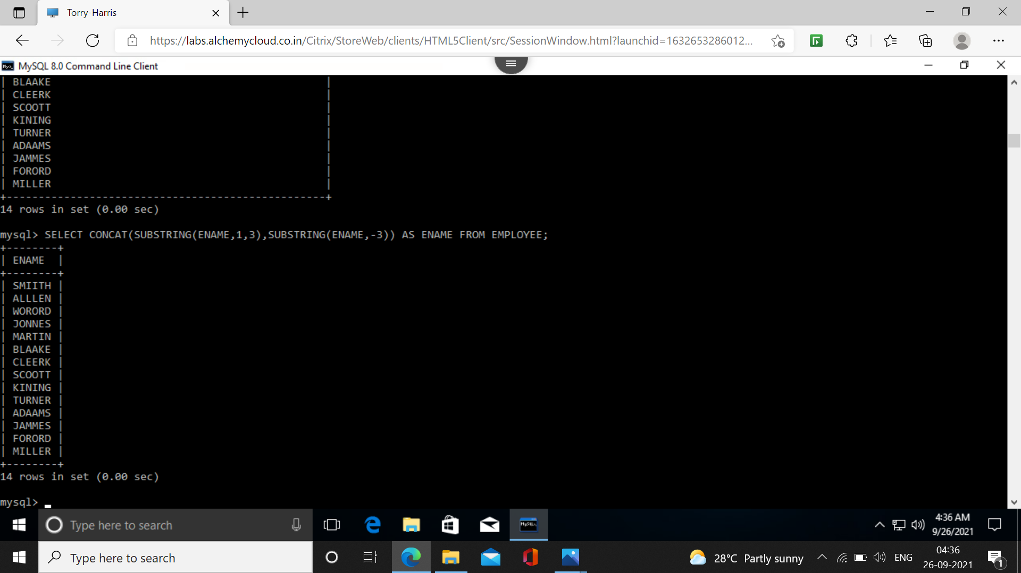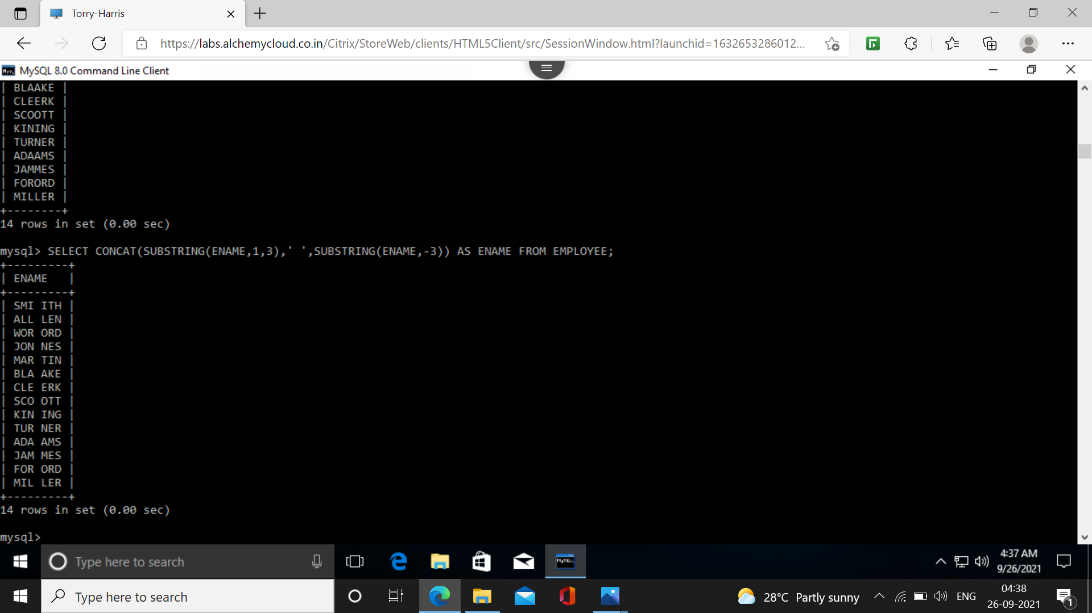**36. Display the names of all the employees replacing ’A’ with ’a’.**

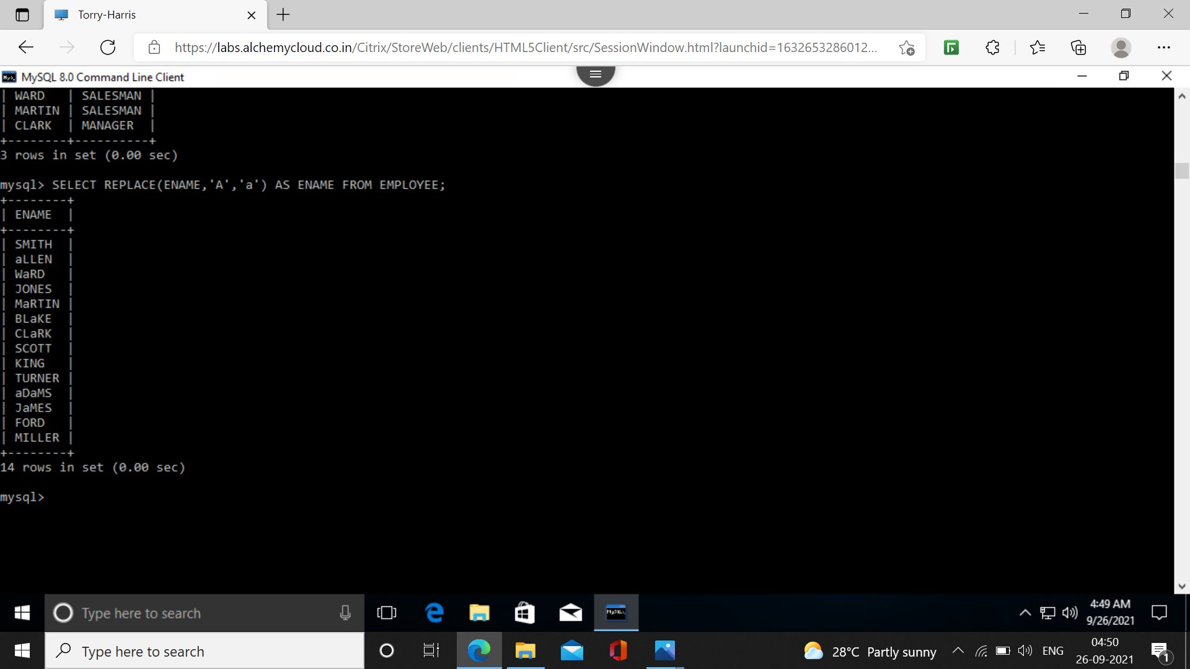**37.Display the names of all the employees and position where the string ’AR’ occurs in the name.**

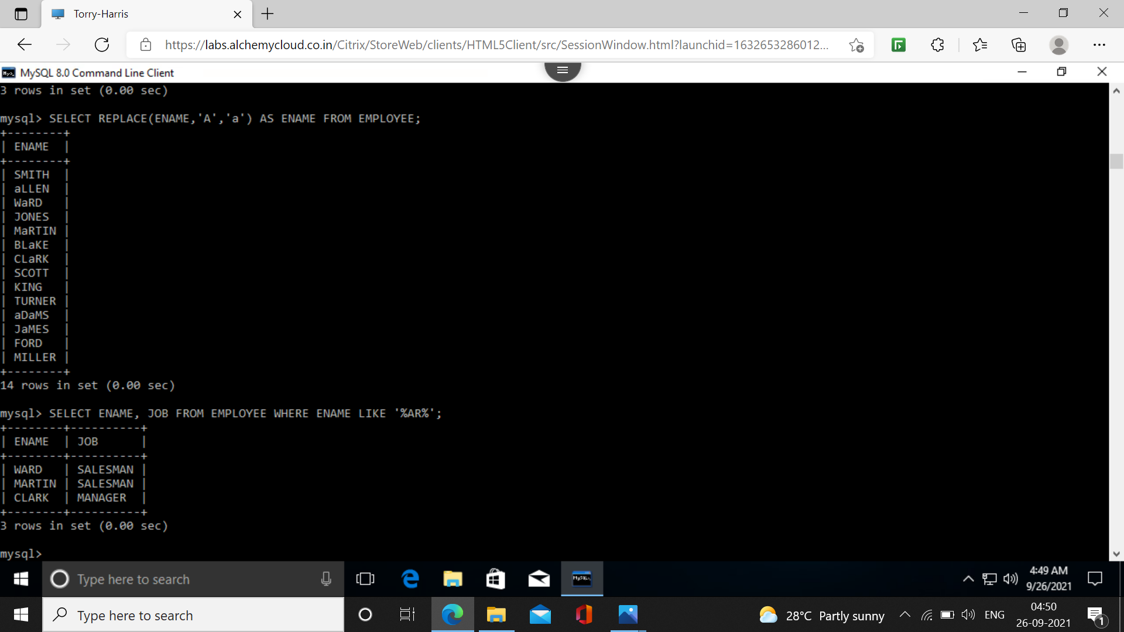**38. Show the salary of all the employees, rounding to the nearest Rs. 1000/-.**

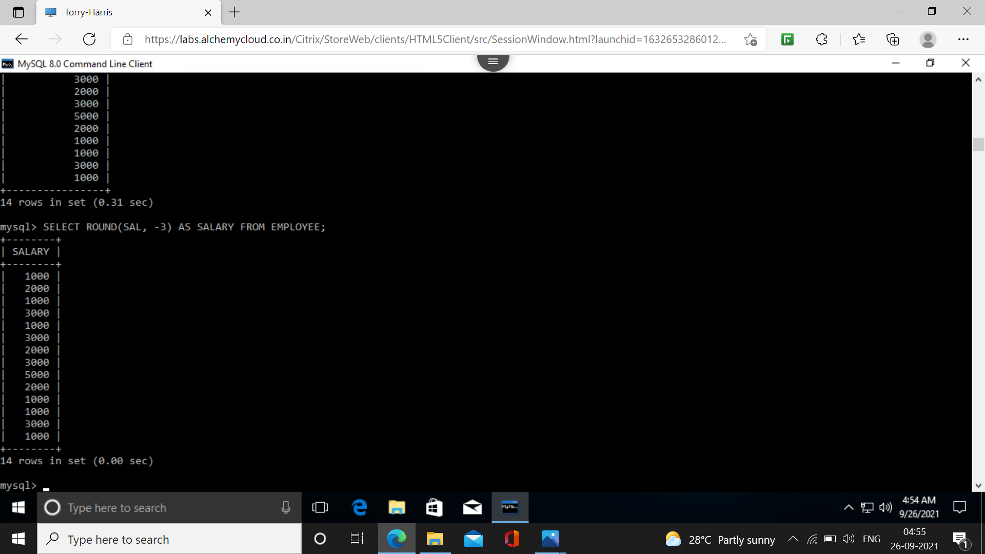**39. Show the salary of all the employees, ignoring the fraction less than Rs. 1000/-.**

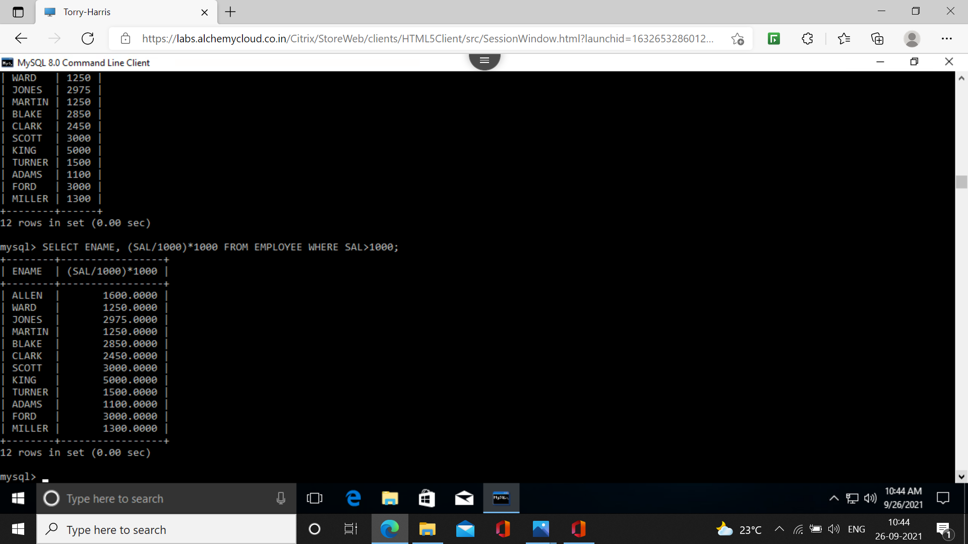**40. Show the names of all the employees and date on which they completed 3 years of service.**

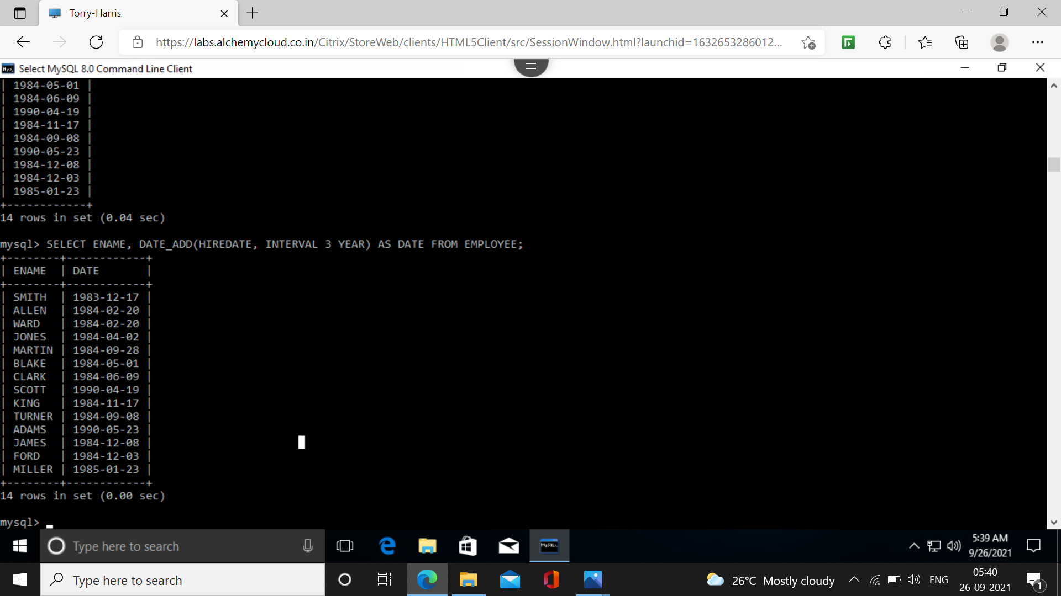**41. For each employee, display the no. Of days passed since the employee joined the company.**

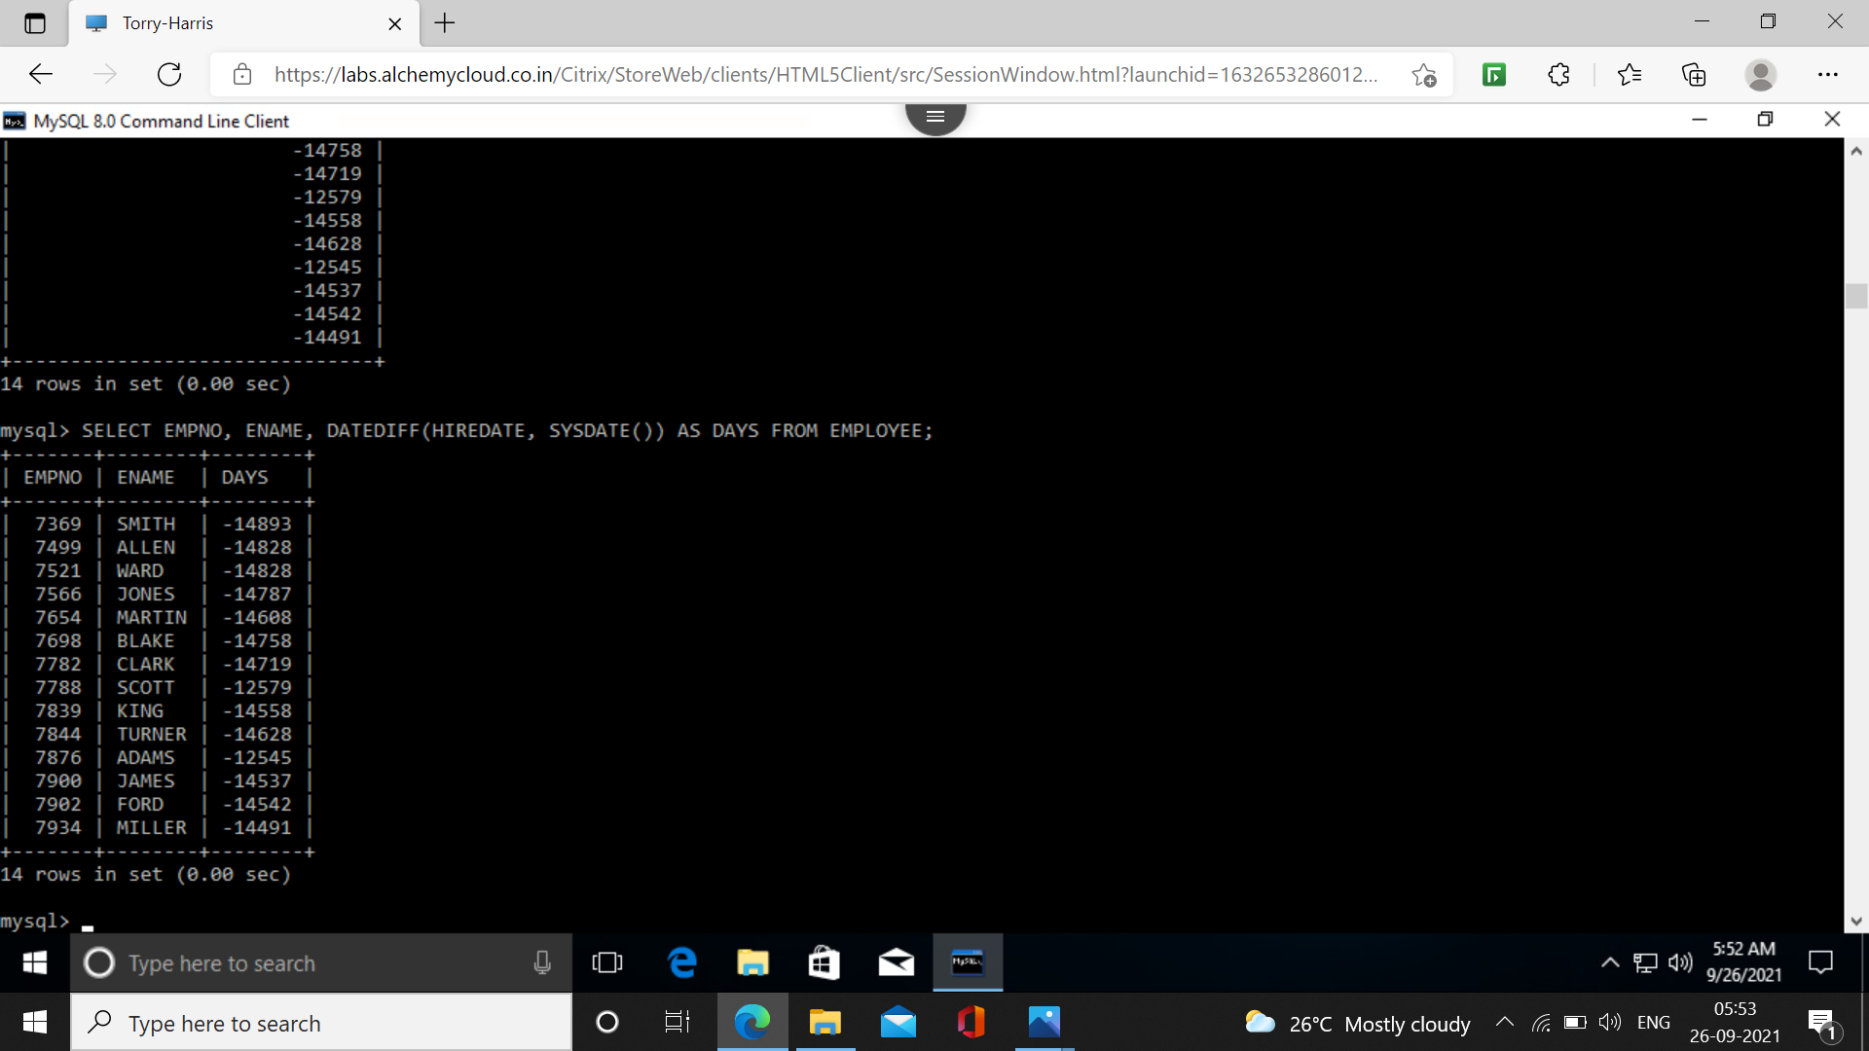**42. For each employee, display the no. Of months passed since the employee joined the company.**

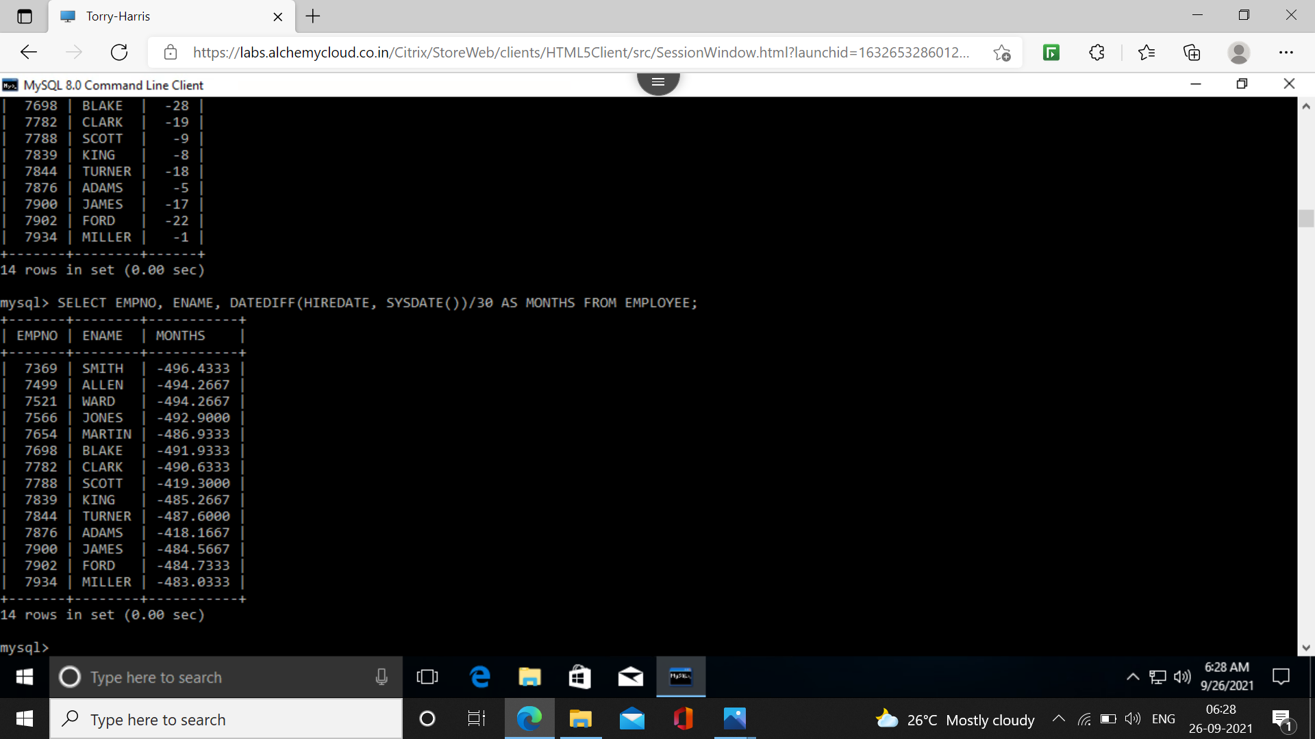**43. Display the details of all the employees sorted on the names.**

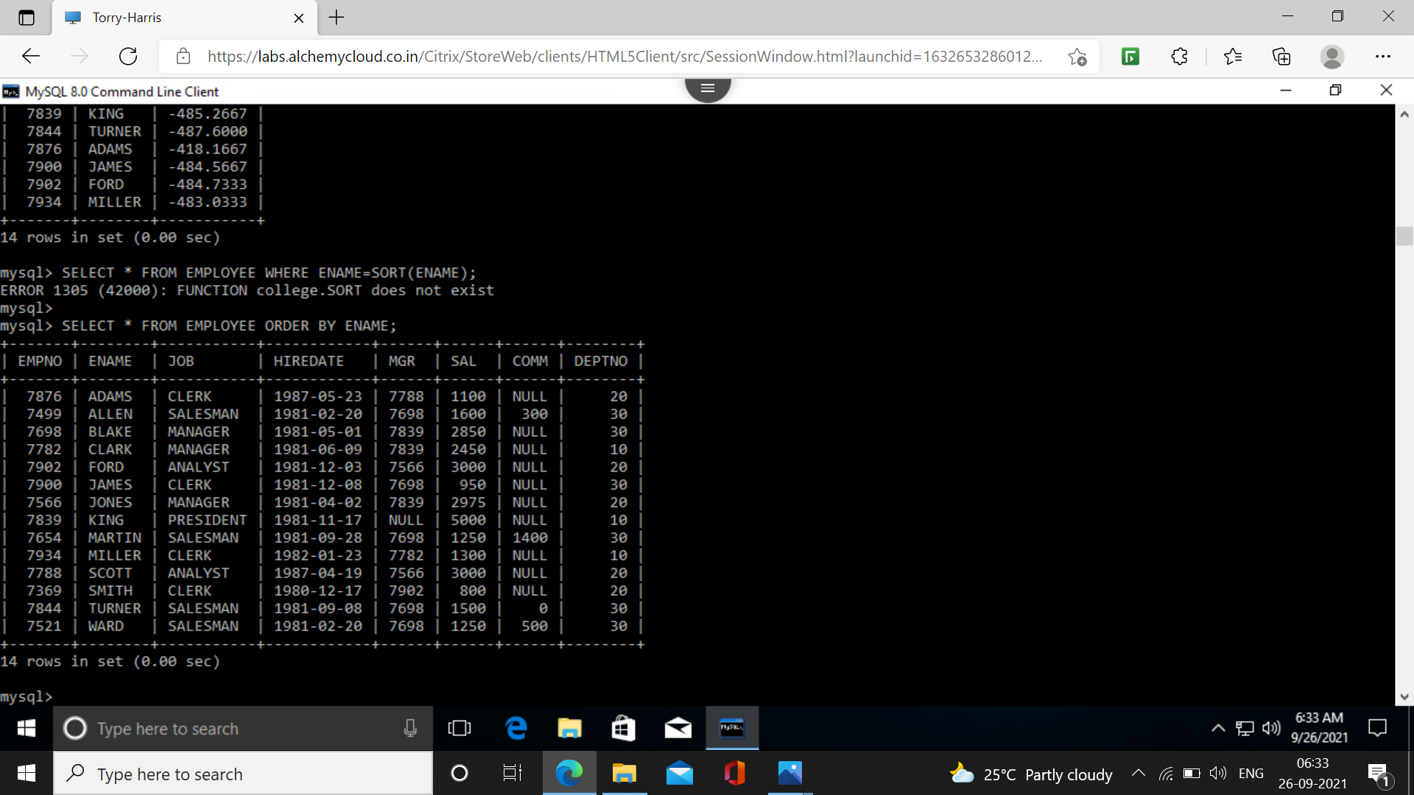**44. Display the names of the employees, based on the tenure with the oldest employee coming first.**

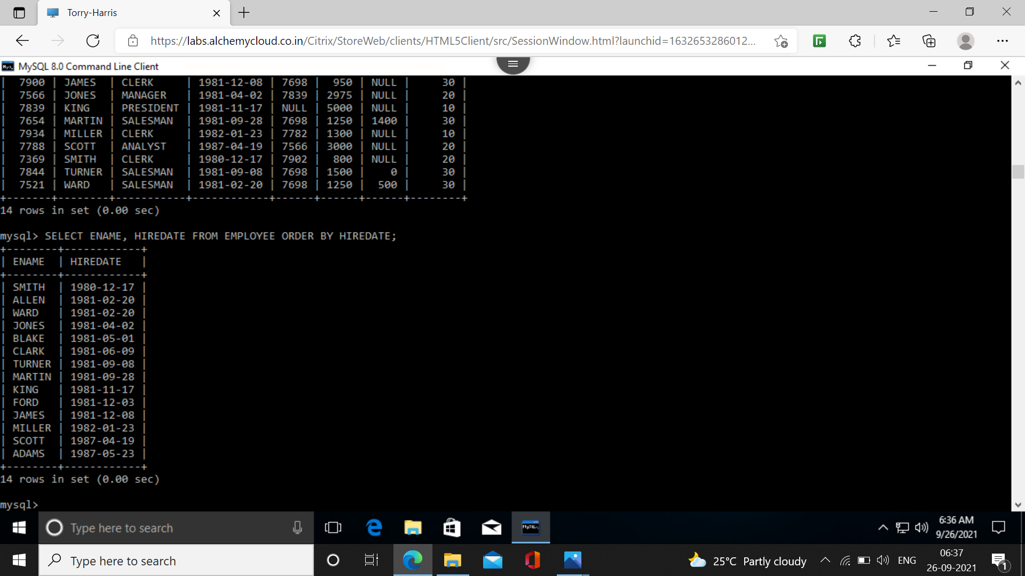**45. Display names, jobs, and salaries of employees, sorting on job and salary.**

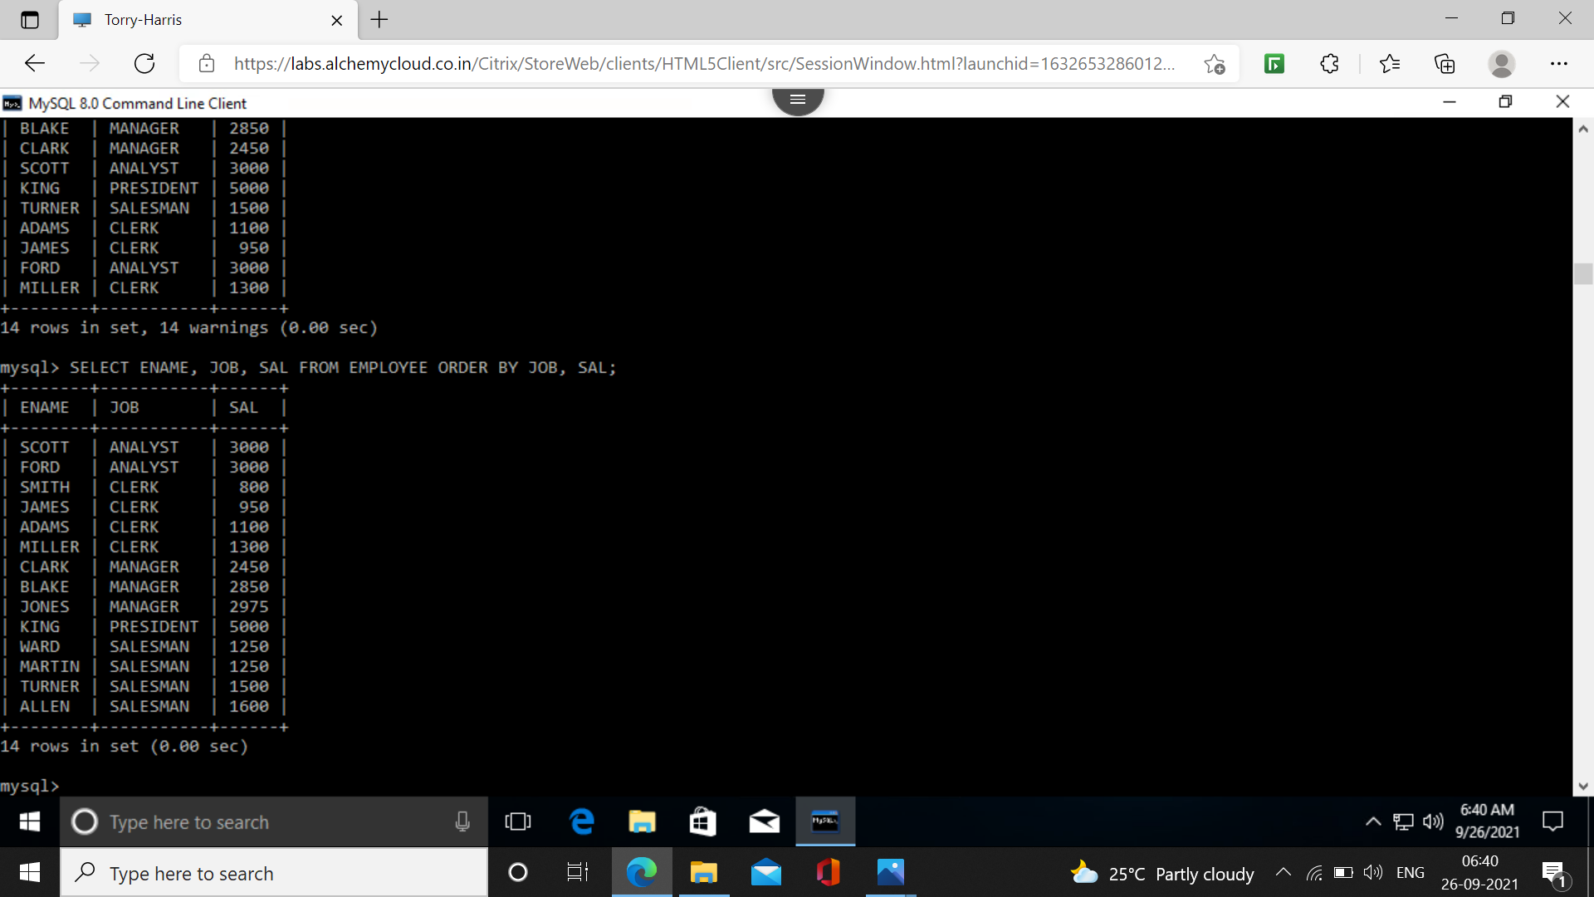**46. Display names, jobs, and salaries of employees, sorting on descending order of job and within job sorted on salary.**

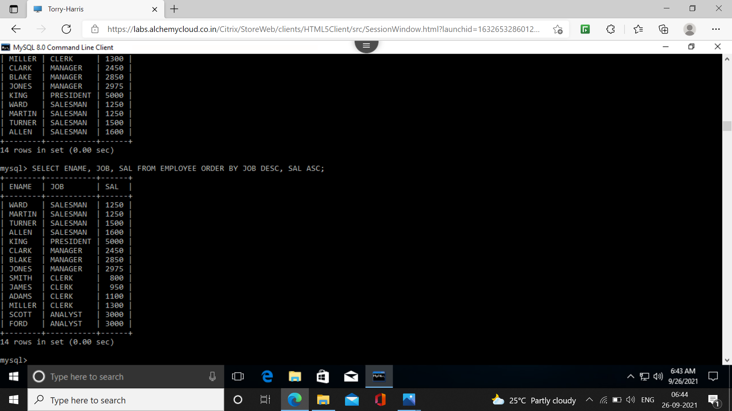**47. List the employee names, department names and salary for those employees who have completed 1 year of service.**

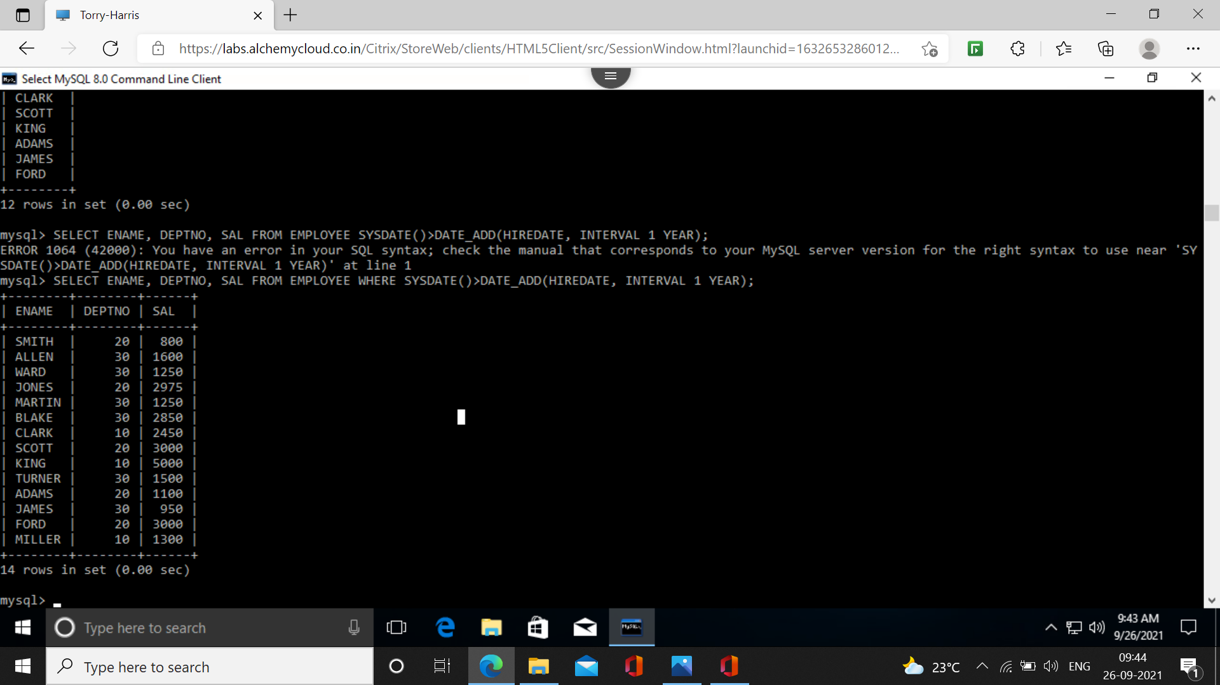**48. List the employee names, department names and salary for those employees who are earning 0 commission or commission is null. Sort your output in the order of department name.**

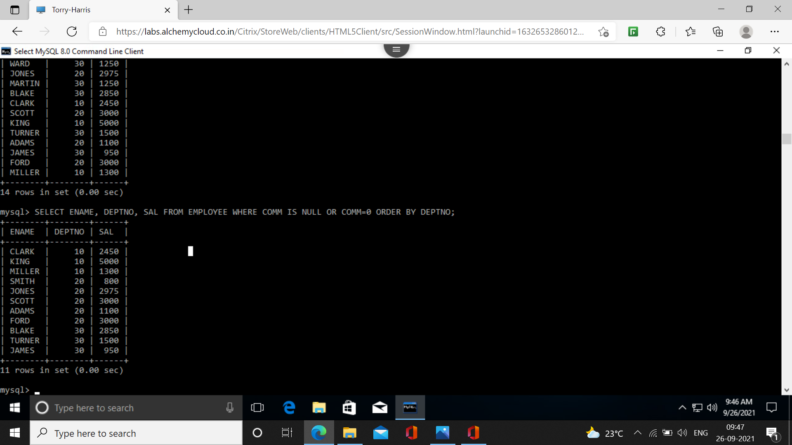**49. List the employees names, department names and hire date for those employees who have joined in 2003. Sort your output in the order of joining date.**

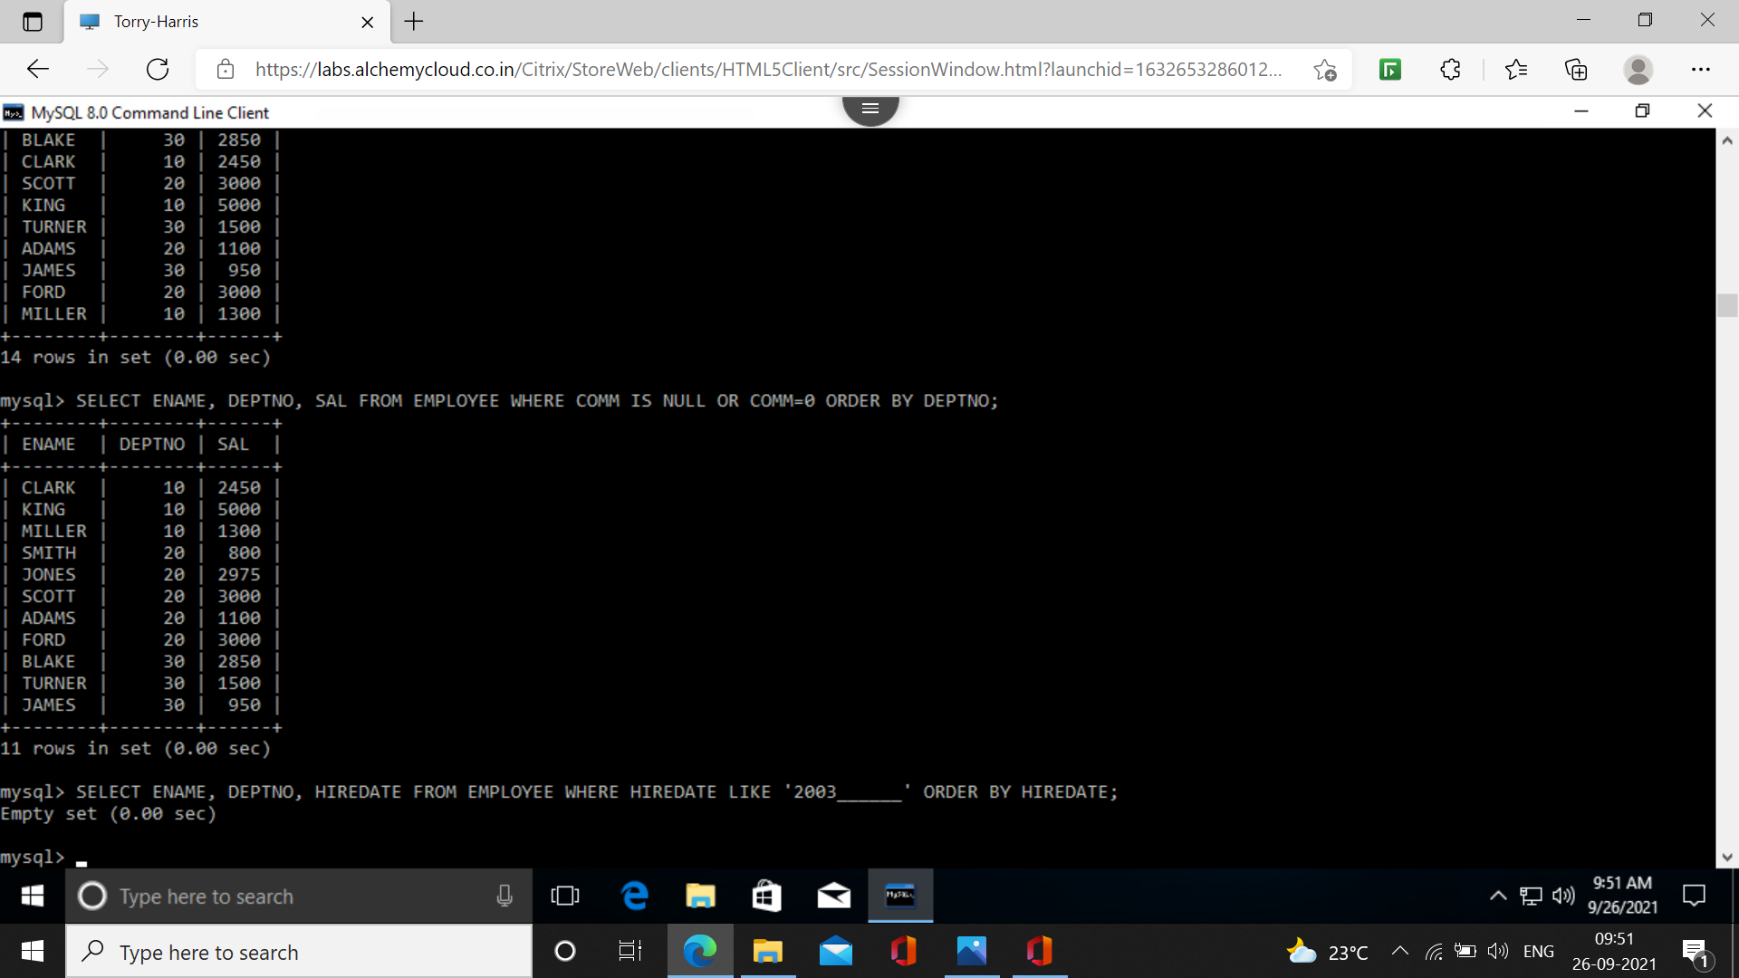**50. List all the department names along with the names of employees in them, irrespective of the fact whether any employee is there or not.**

